**ASSIGNMENT-11**

NAME – KONAKALLA AKHILA

ROLLNO – DXC-262AB-1225

BATCH – DXC-262-ANALYTICS-B12-AZURE

**1. Write a python program to predict car sales of a company by using below data,**

**year : 2010 2011 2012 2013 2014 2015 2016 2017 2018 2019 2020  
Sales in millions: 169 199 262 301 345 398 501 595 610 700 720  
display outcome using linear regression method**

import matplotlib.pyplot as plt

import numpy as np

#import model from scikit-learn

from sklearn import linear_model

#loading datasets

car_price=[169 ,199, 262, 301, 345, 398, 501, 595, 610, 700, 720]

year_car=[2010, 2011, 2012, 2013, 2014 ,2015, 2016, 2017, 2018, 2019, 2020]

print(year_car)

#reshape data into input

new_car_year=np.array(year_car).reshape((-1,1))

print(new_car_year)

load model

reg_model=linear_model.LinearRegression()

#fit data into model

reg_model.fit(new_car_year,car_price)

#coefficient

print("coefficient:",reg_model.coef_)

#intercept

print("intercept:",reg_model.intercept_)

def graph(formula,x_range):

  x=np.array(x_range)

  y=eval(formula)

  plt.plot(x,y)

#plotting the predictions

graph('reg_model.coef_*x+reg_model.intercept_',range(1000,2700))

plt.scatter(new_car_year,car_price,color='red')

plt.ylabel("car price")

plt.xlabel("Year of car")

plt.show()

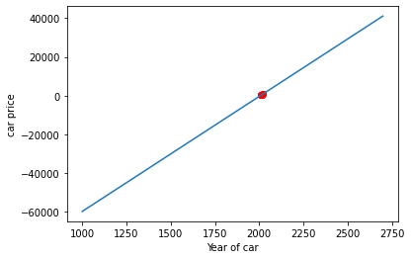

**2. Write python program to generate possible tuples from any two sample Lists**

**Code for deploying it:**

test_tuple1 = (9,23)

test_tuple2 = (19,13)

print("The original Tuple 1 is : "+str(test_tuple1)) print("The original Tuple 2 is : "+str(test_tuple2)) res = [(a,b) for a in test_tuple1 for b in test_tuple2]

res = res + [[(a,b) for a in test_tuple2 for b in test_tuple1]] print ("The Filtered Tuple is :" +str(res))

**3. Create Azure Databricks & try to connect databricks & powerBI ,explain the steps with screenshots.**

First create a azure databricks.Click on create.

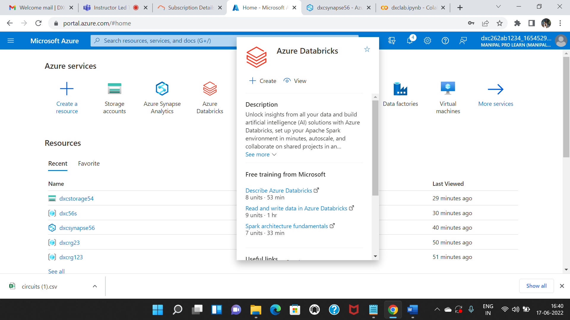

Fill the details and click on review_create.

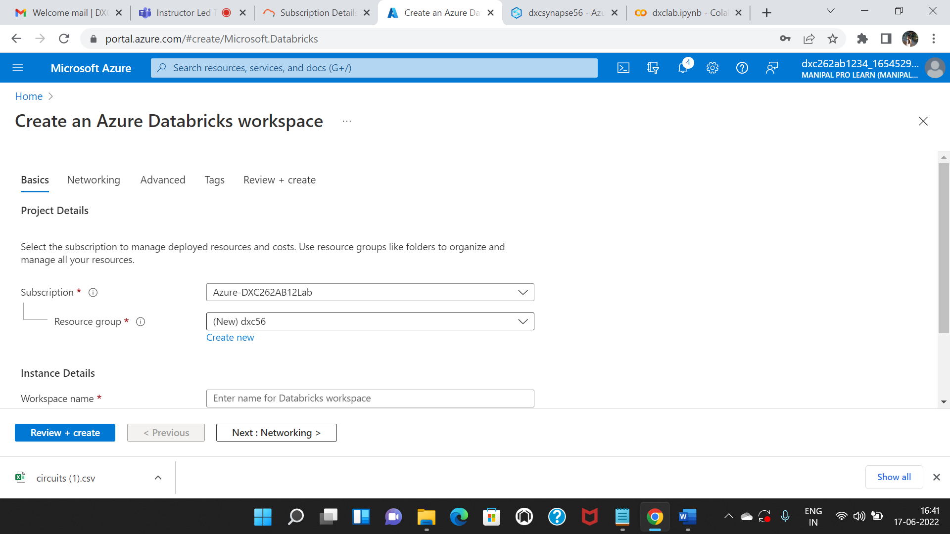

After validation successful click on create.Then the deployment process as started.

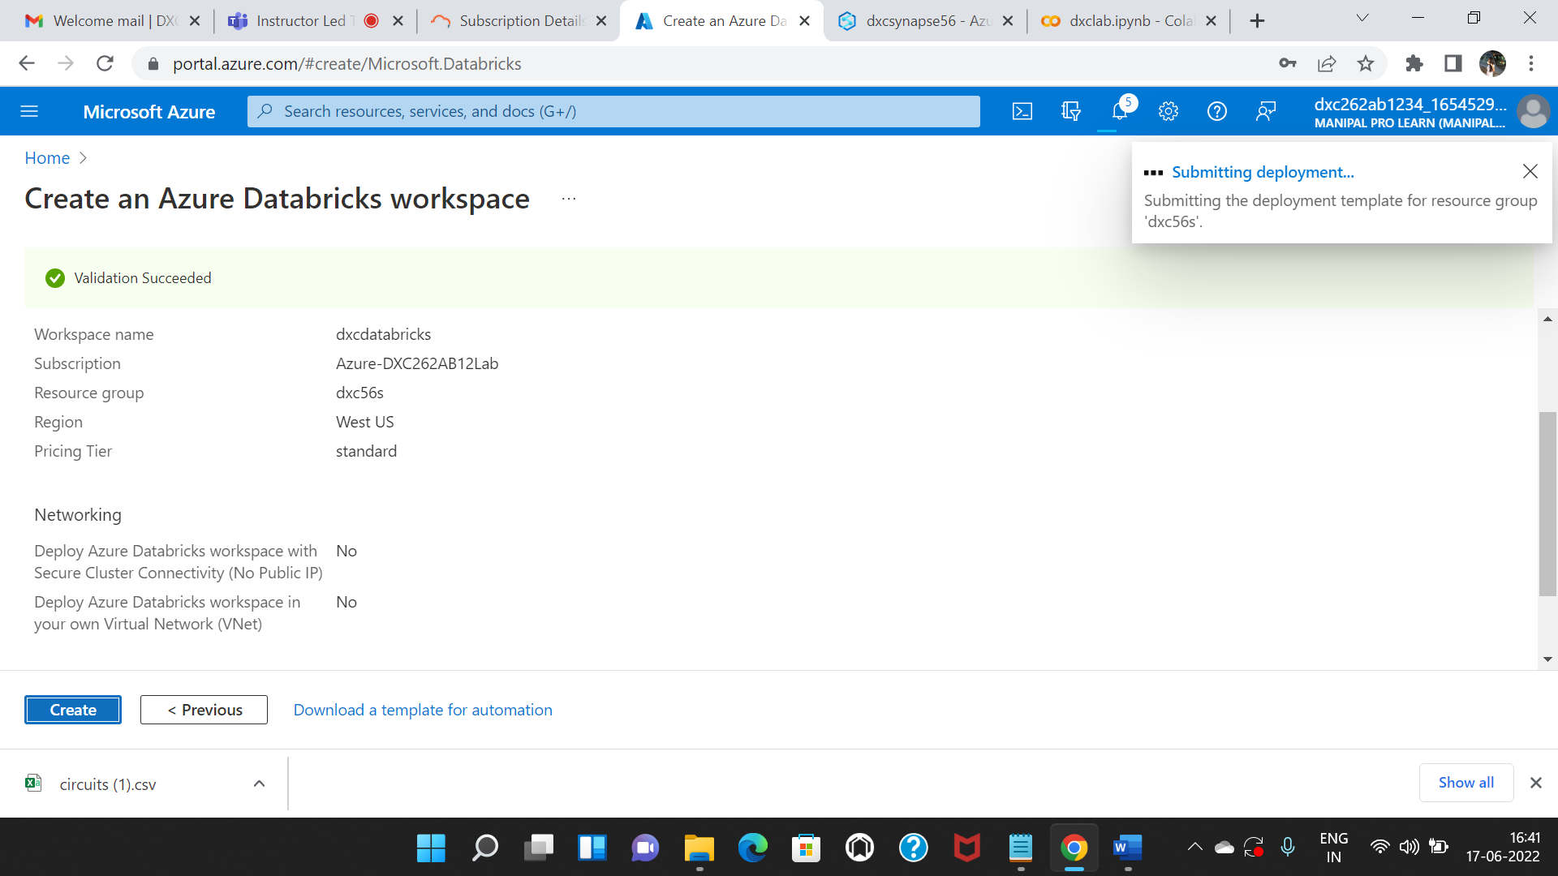

Completion of deployment click on go to resources.

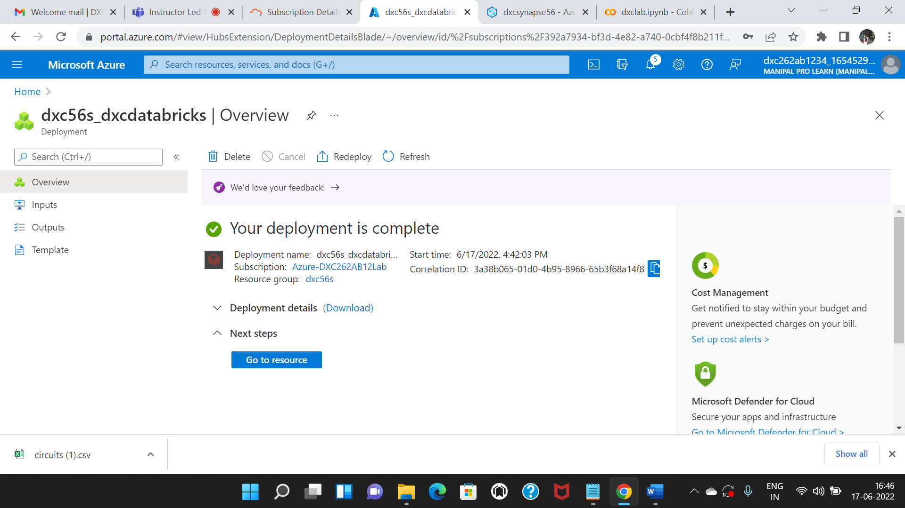

Click on launch workspace.

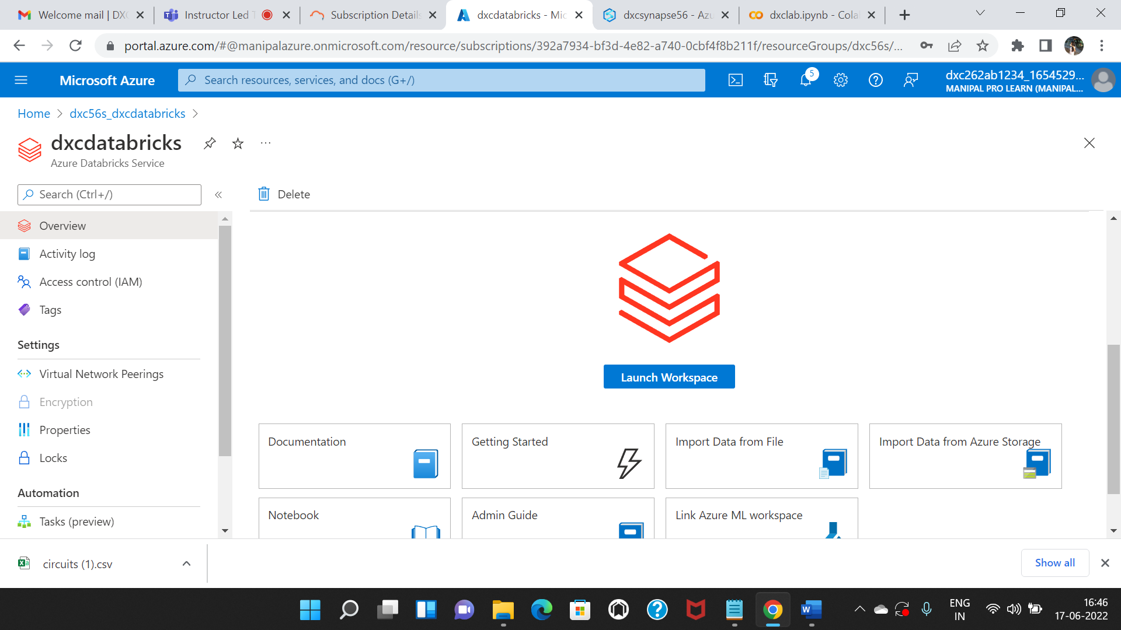

Here we have to create a cluster.

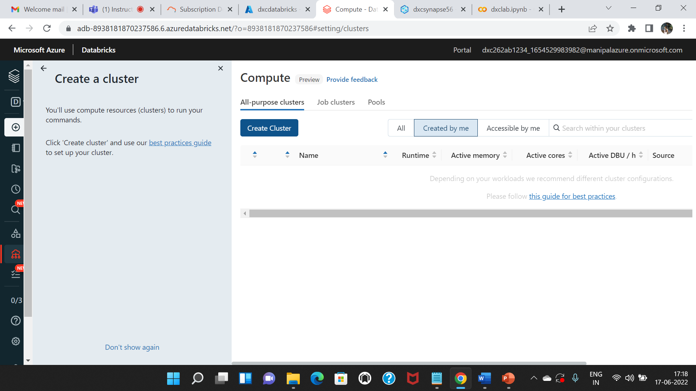

Cluster is successfully created. 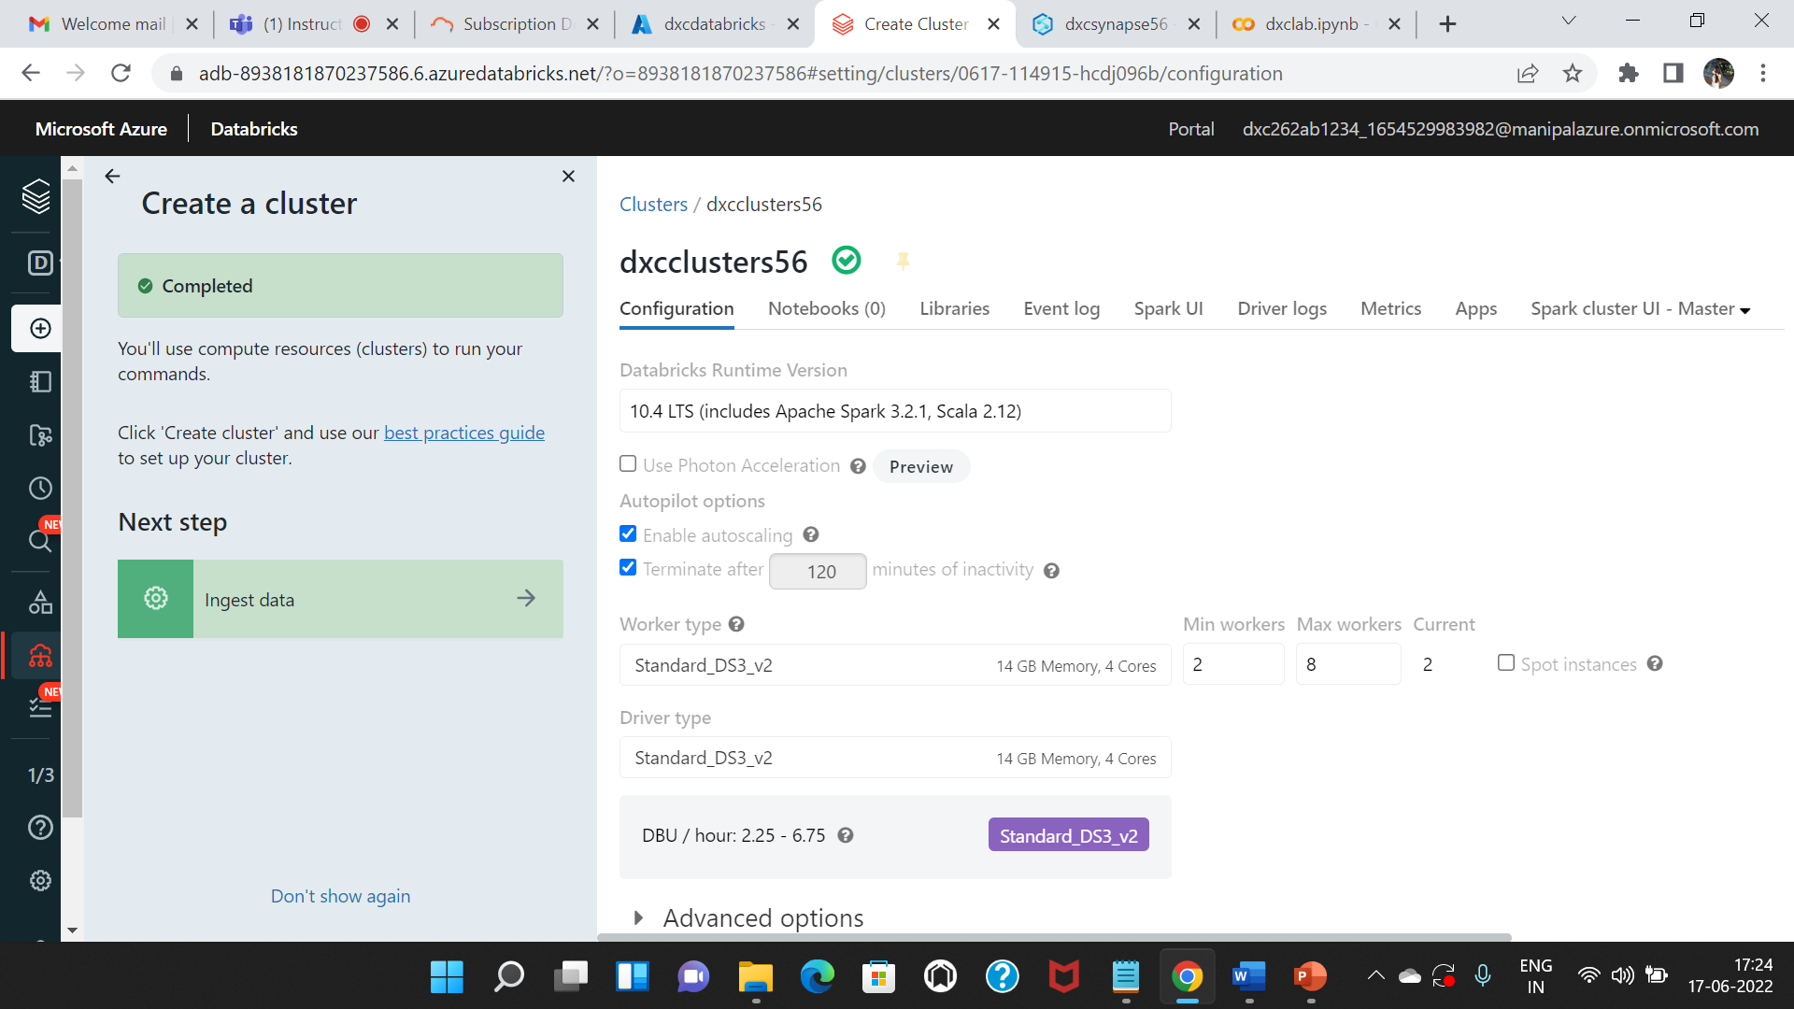

Now, we need to create a table. While creating this table, we need to click on Partner Connect option to connect it with Power BI.

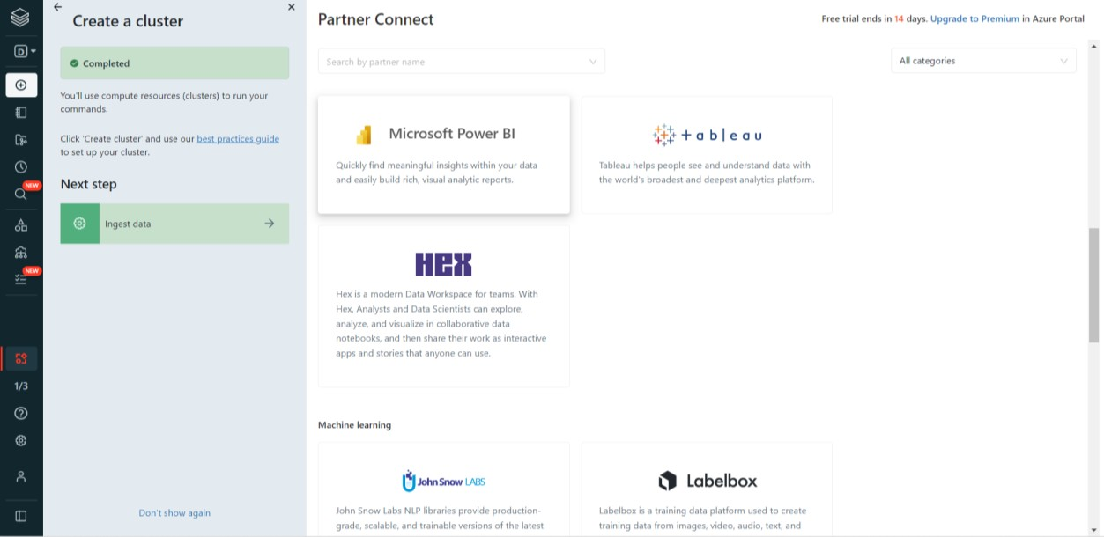

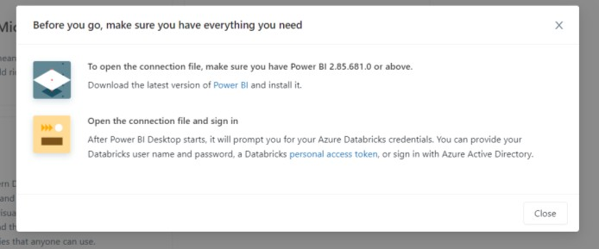

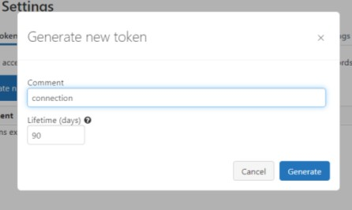

Open the connection file and login using the access token. Now, you can load the data and perform analytics on it. We can plot and verify the data and present it in different formats.

**4.Create Azure Synapse & connect with Azure Blob, explain the steps with screenshots**

Create a azure synapse analytics and click on create

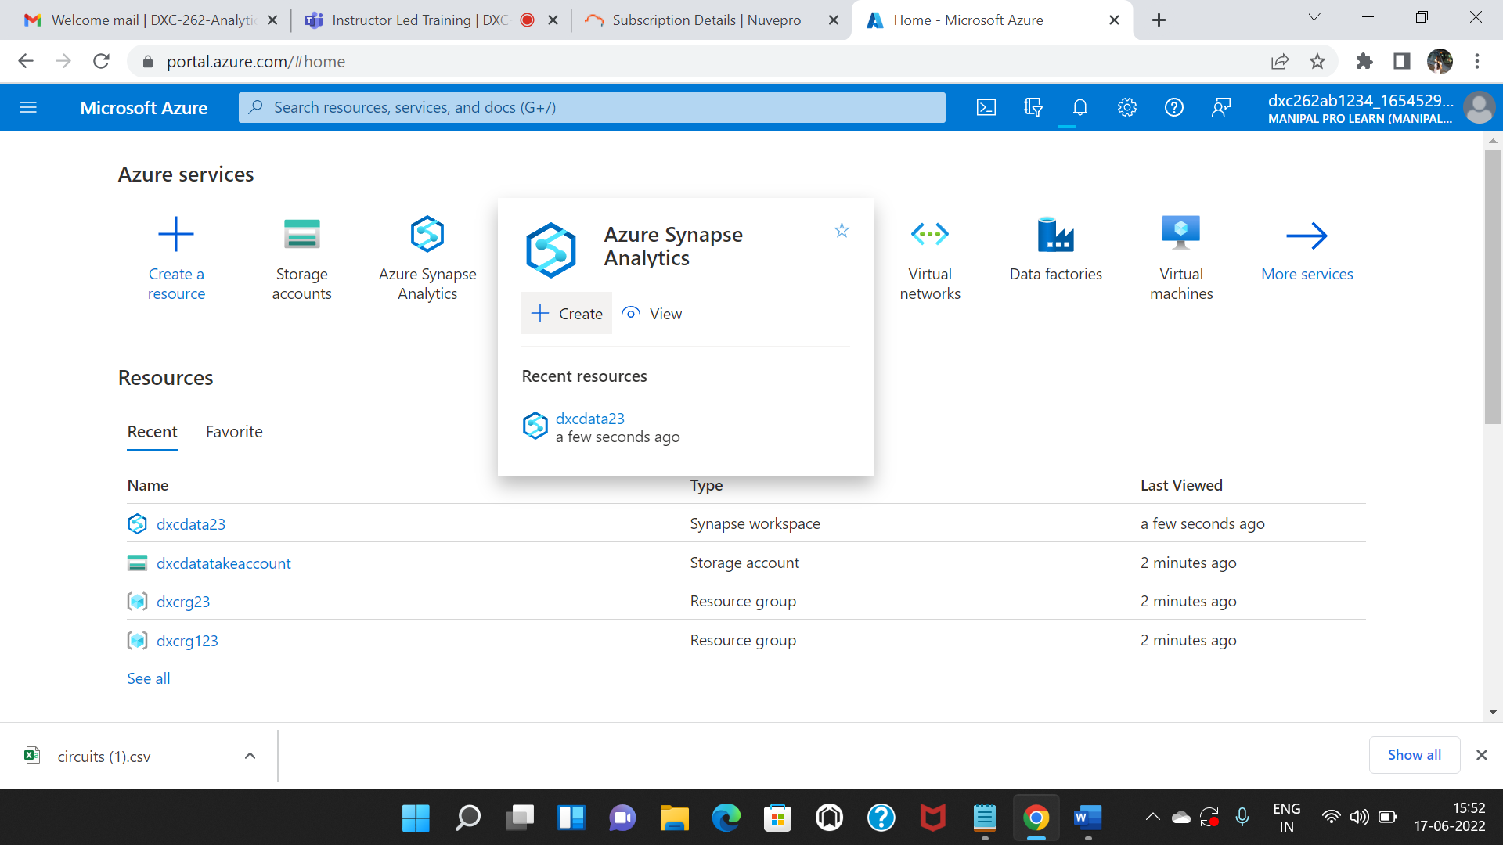

Fill the following details in basics and move to security

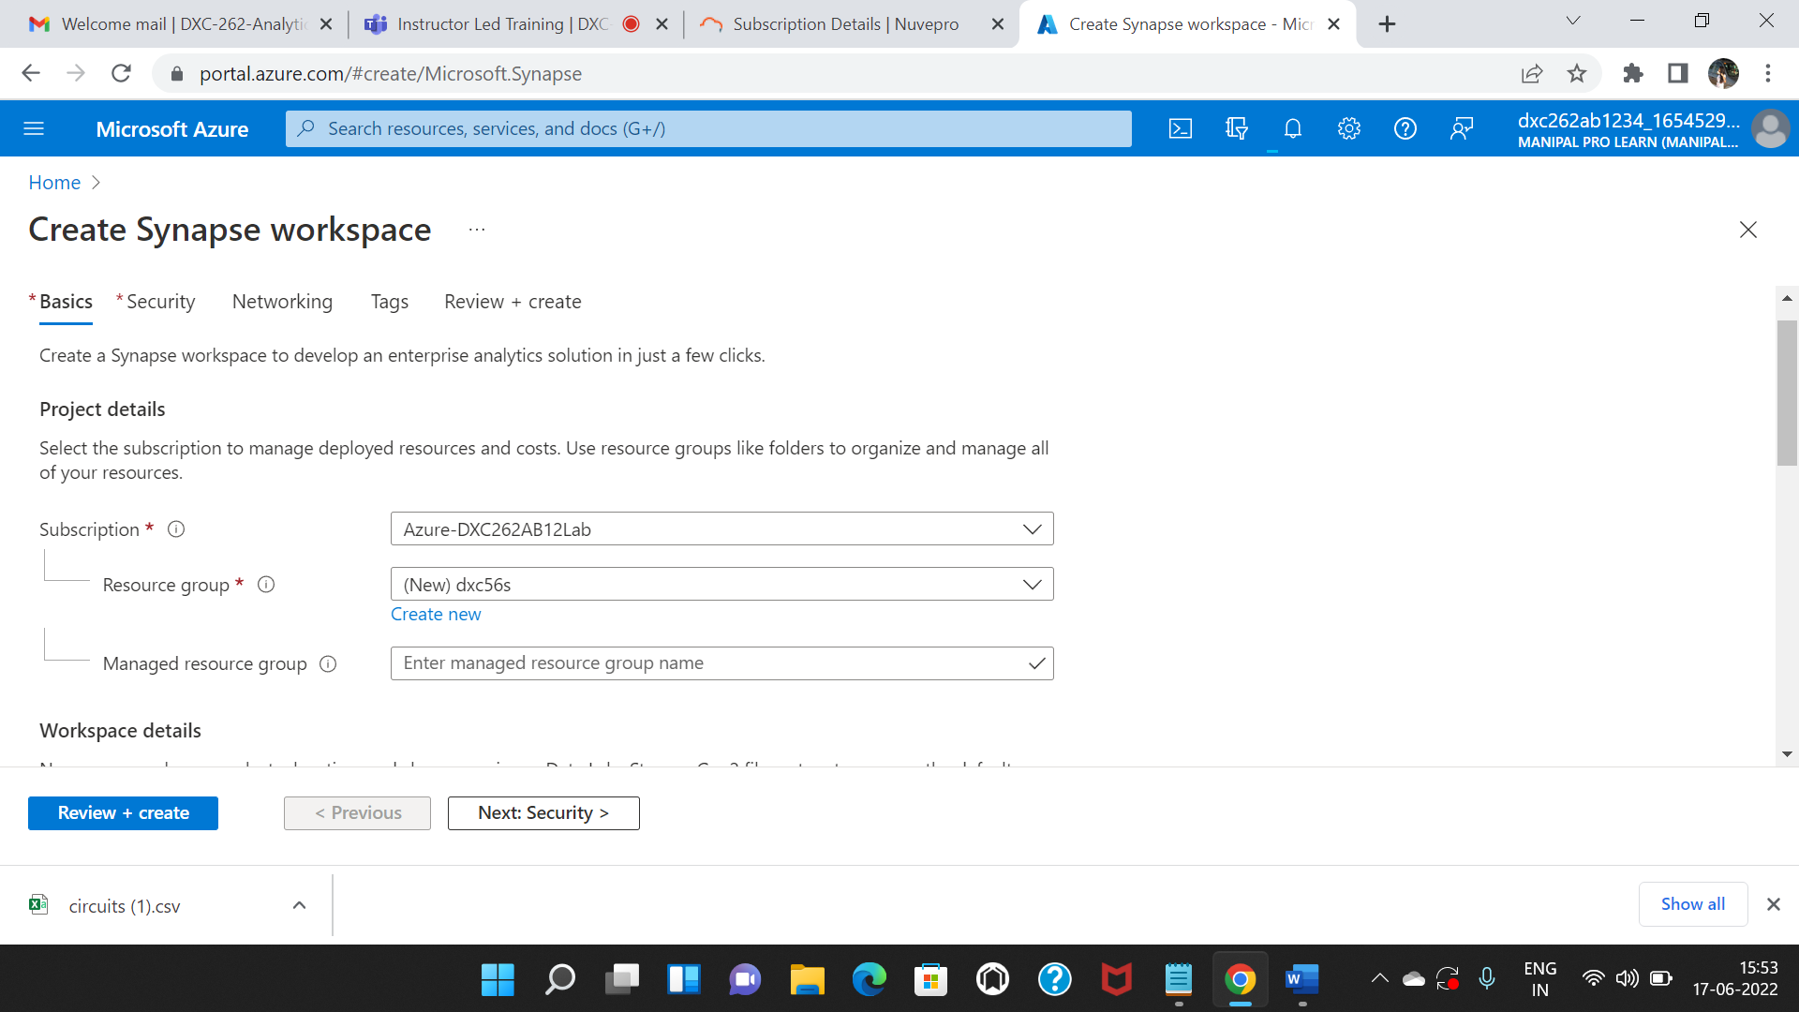

In the security create password.

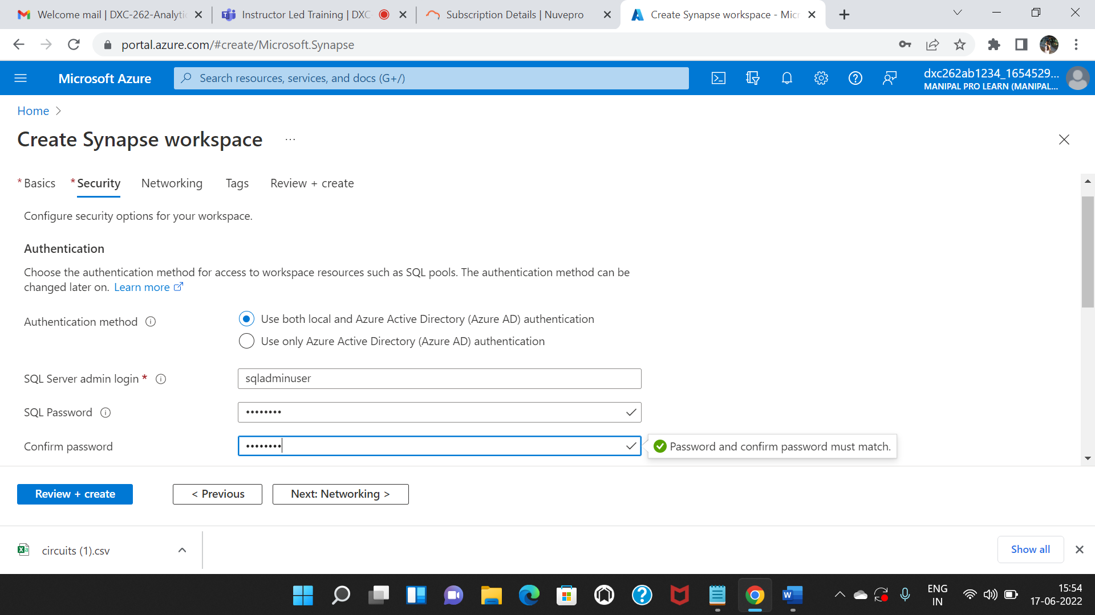

Click on review+create.

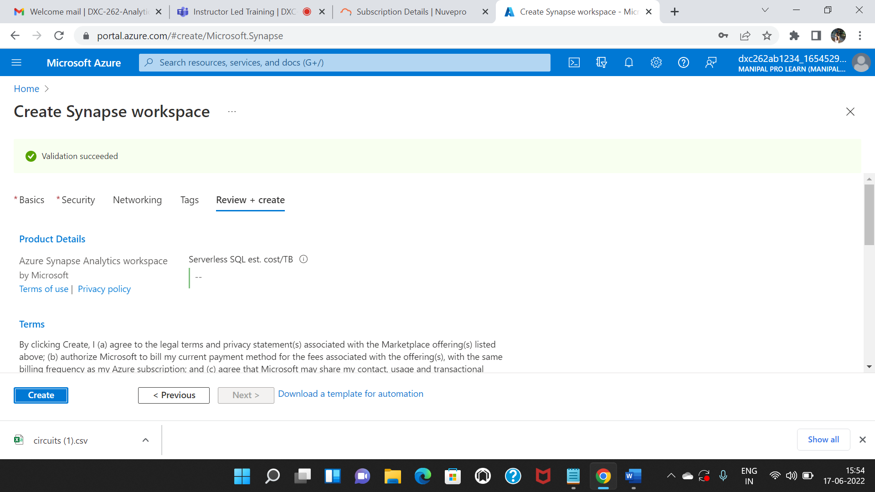

Deployments has started .After completion of deployment click on go to resources

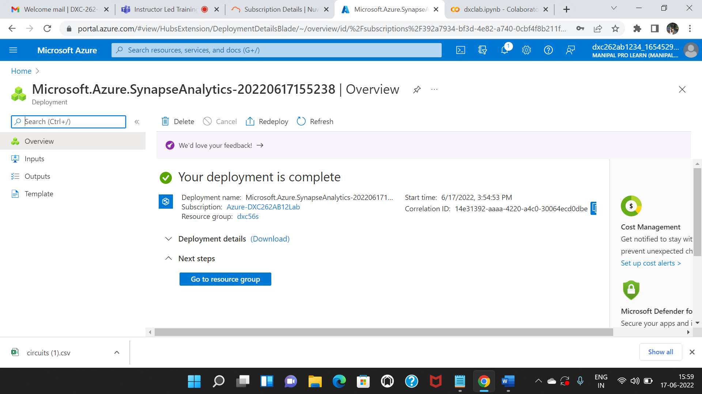

Click on open synapse studio.

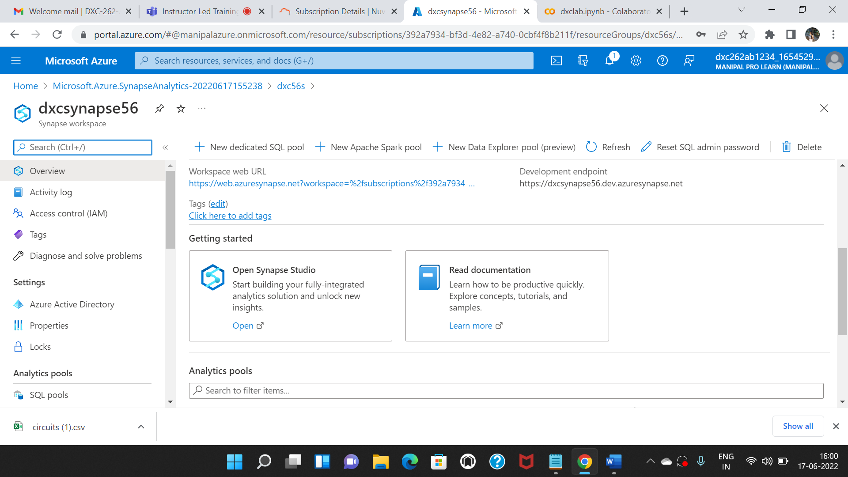

Click on the data which is present on the left side.click on linked and then select connect external data.In that select the azure storage blob.

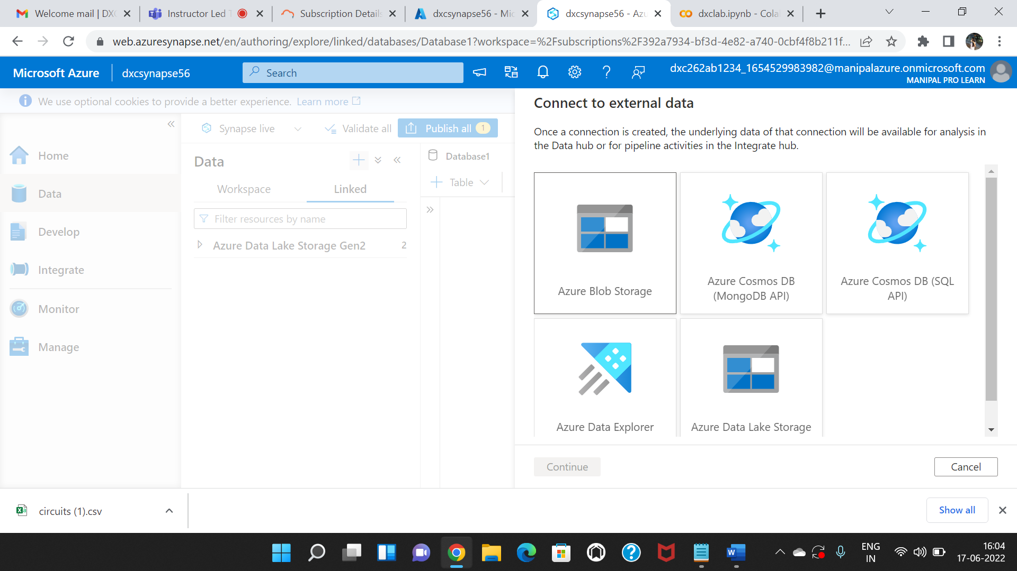

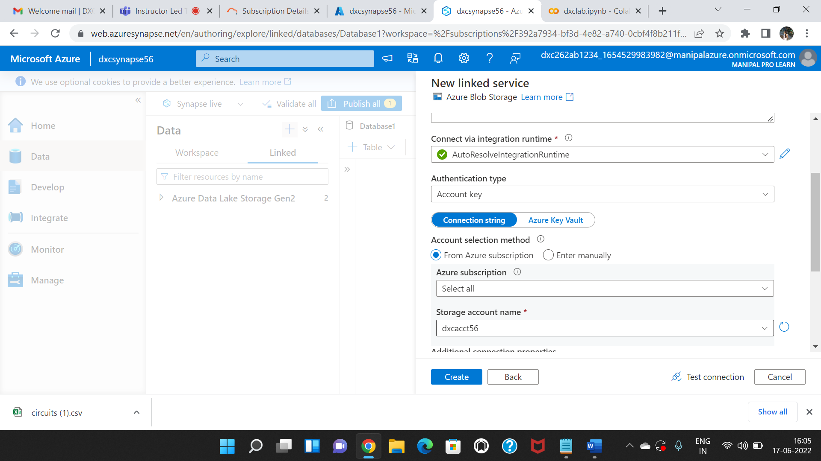

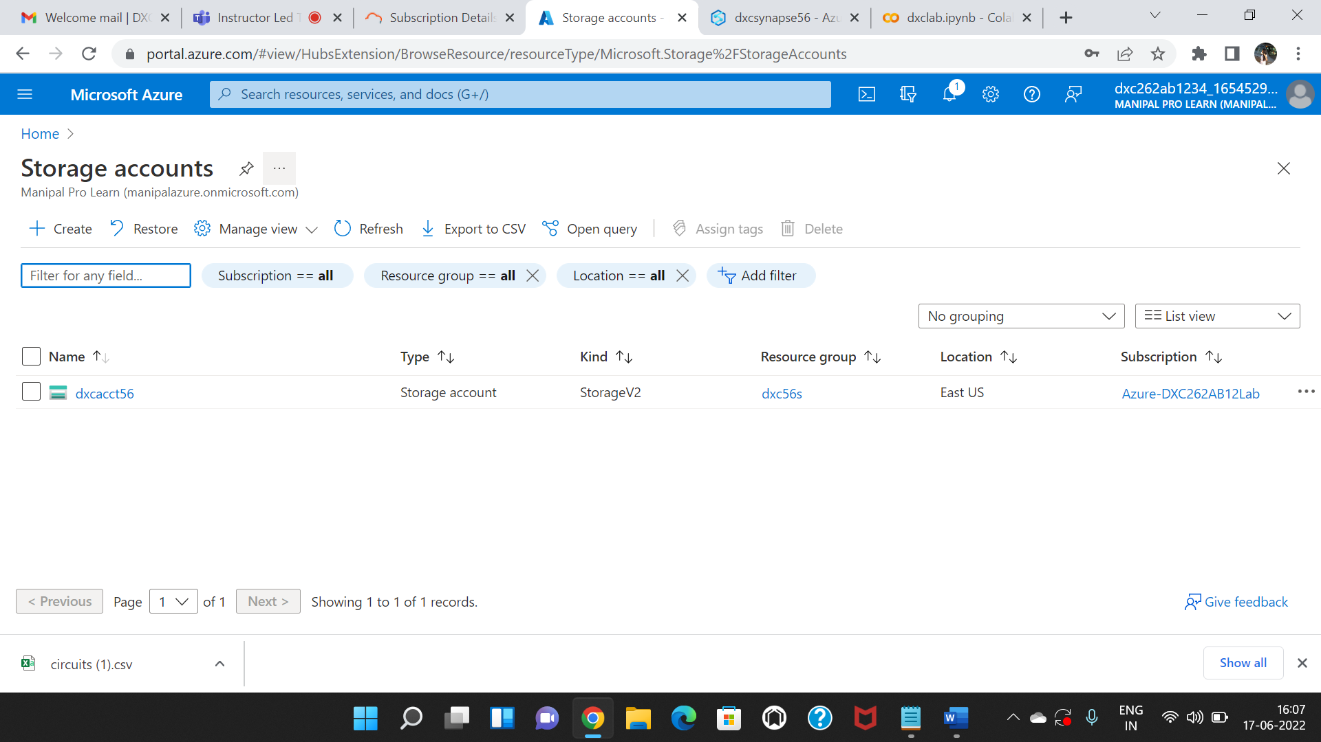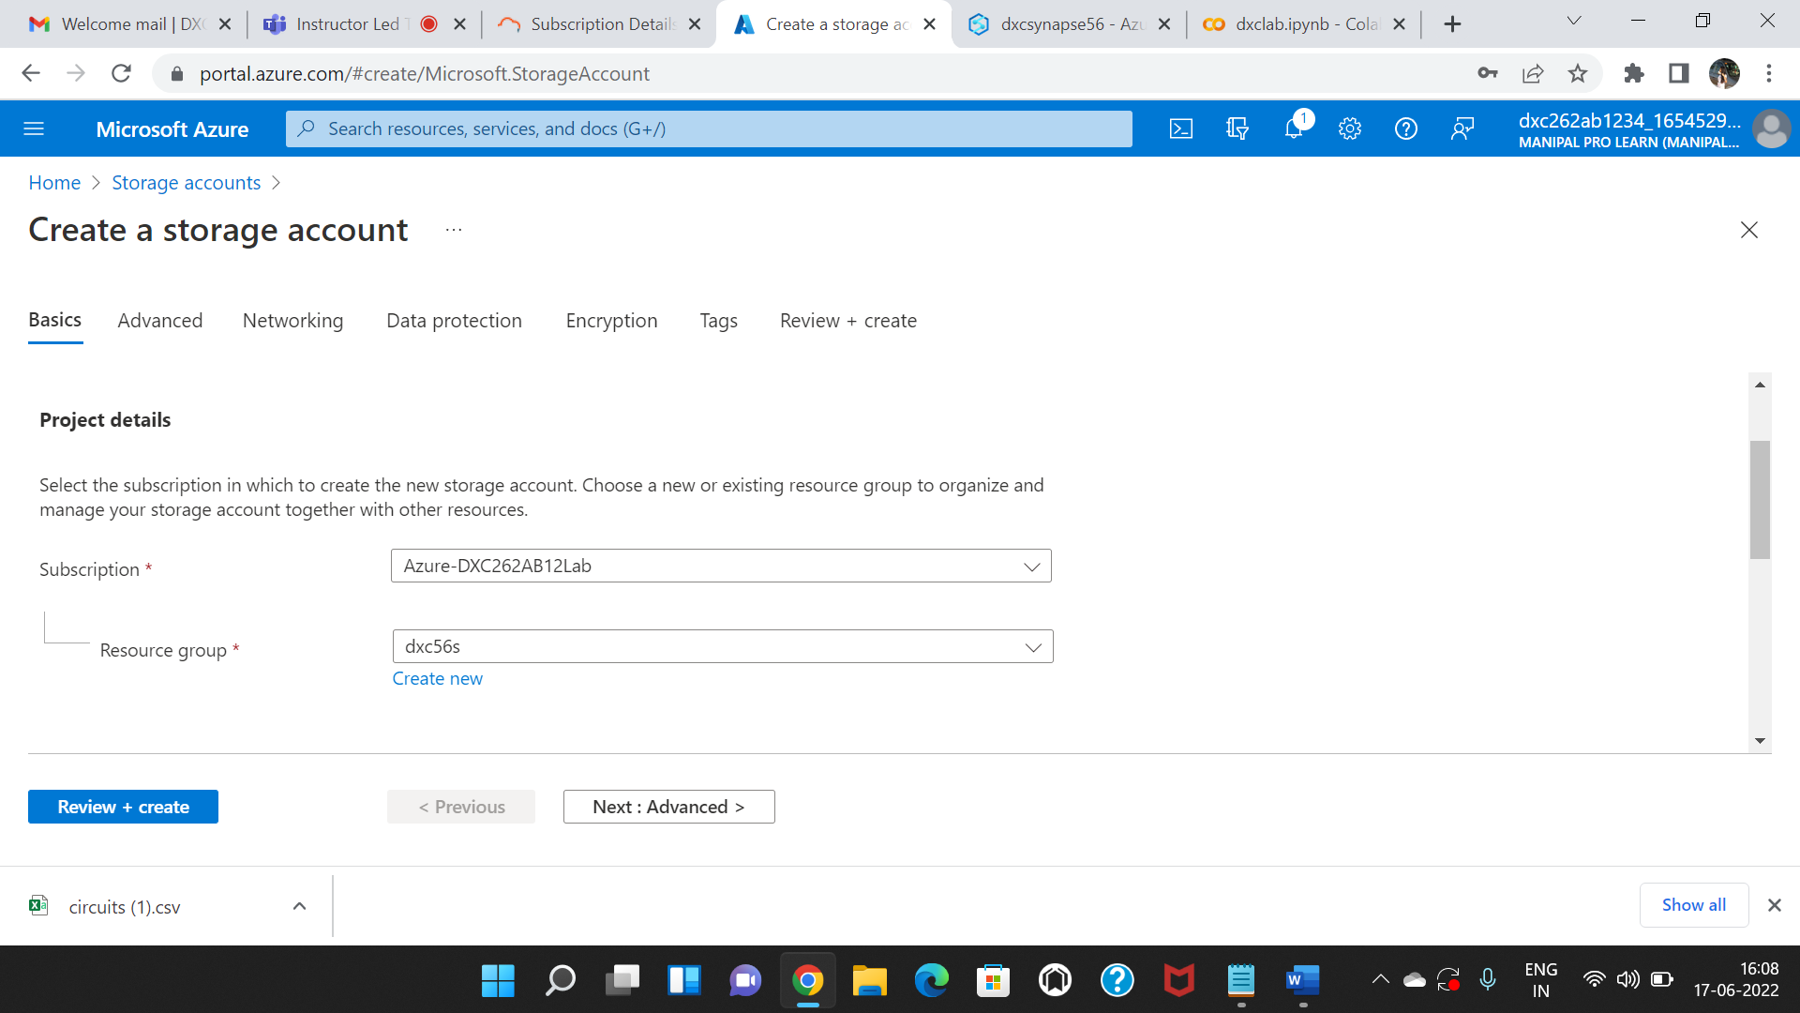

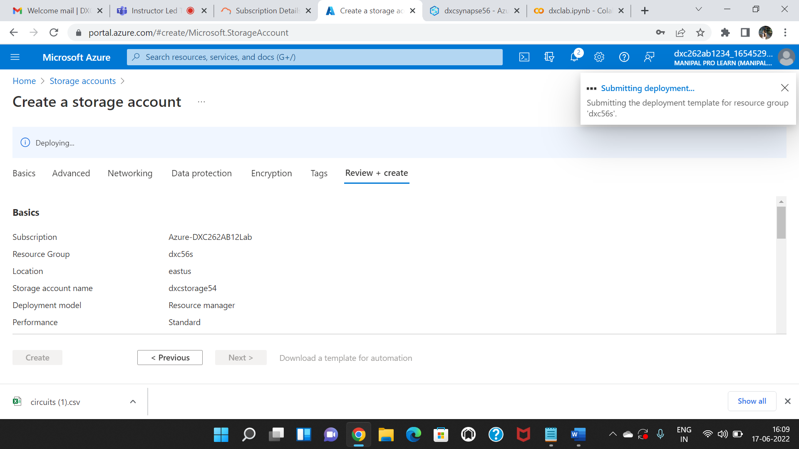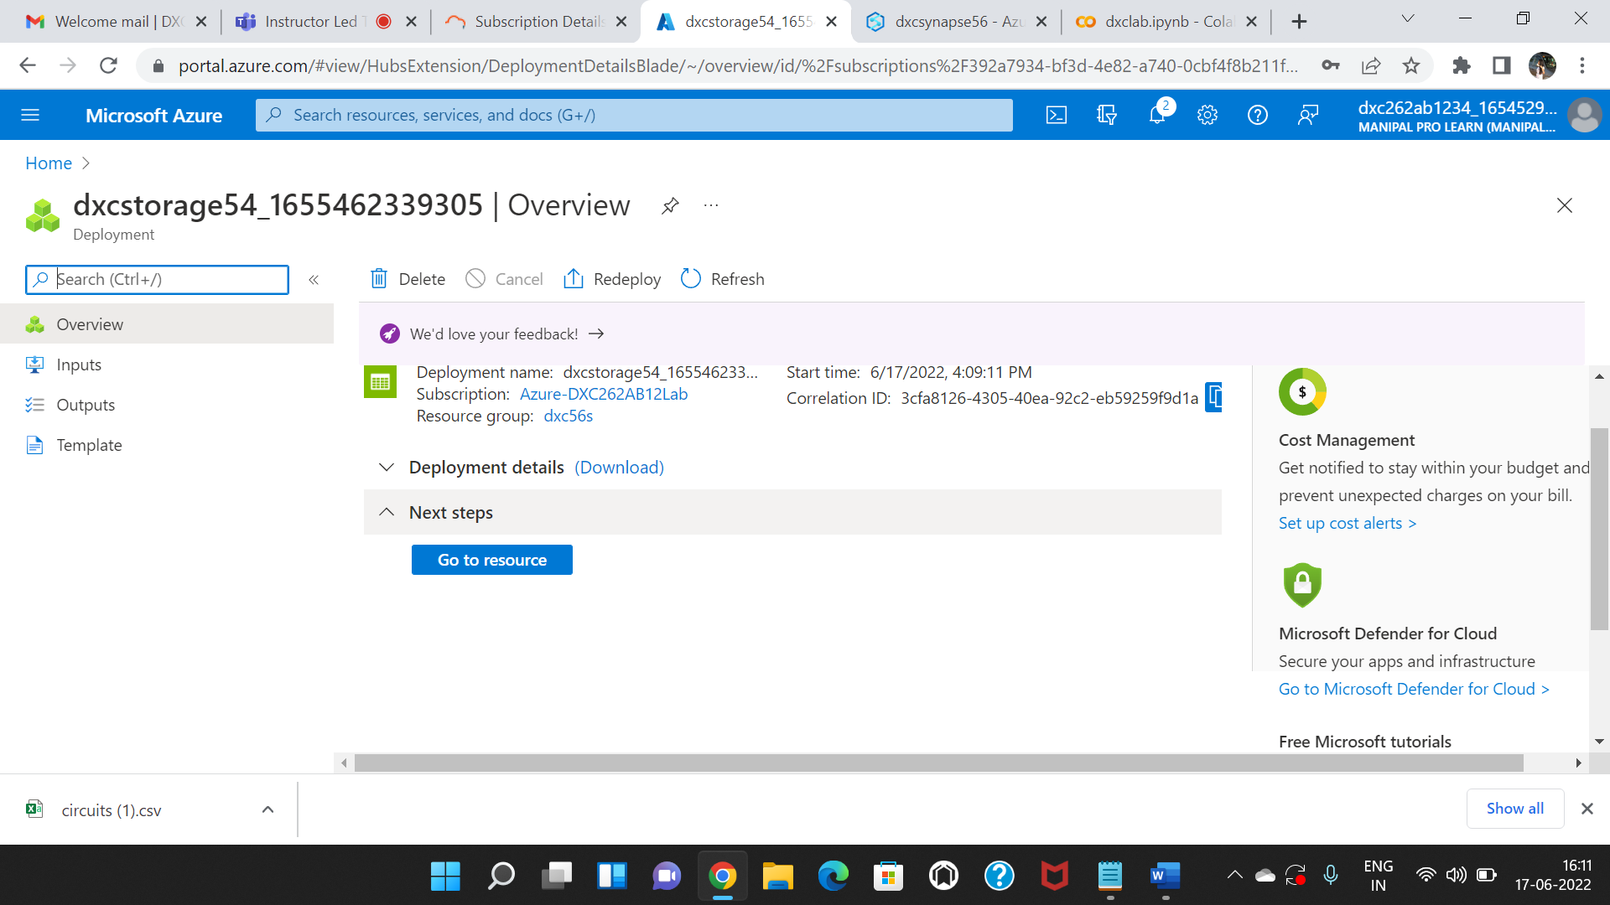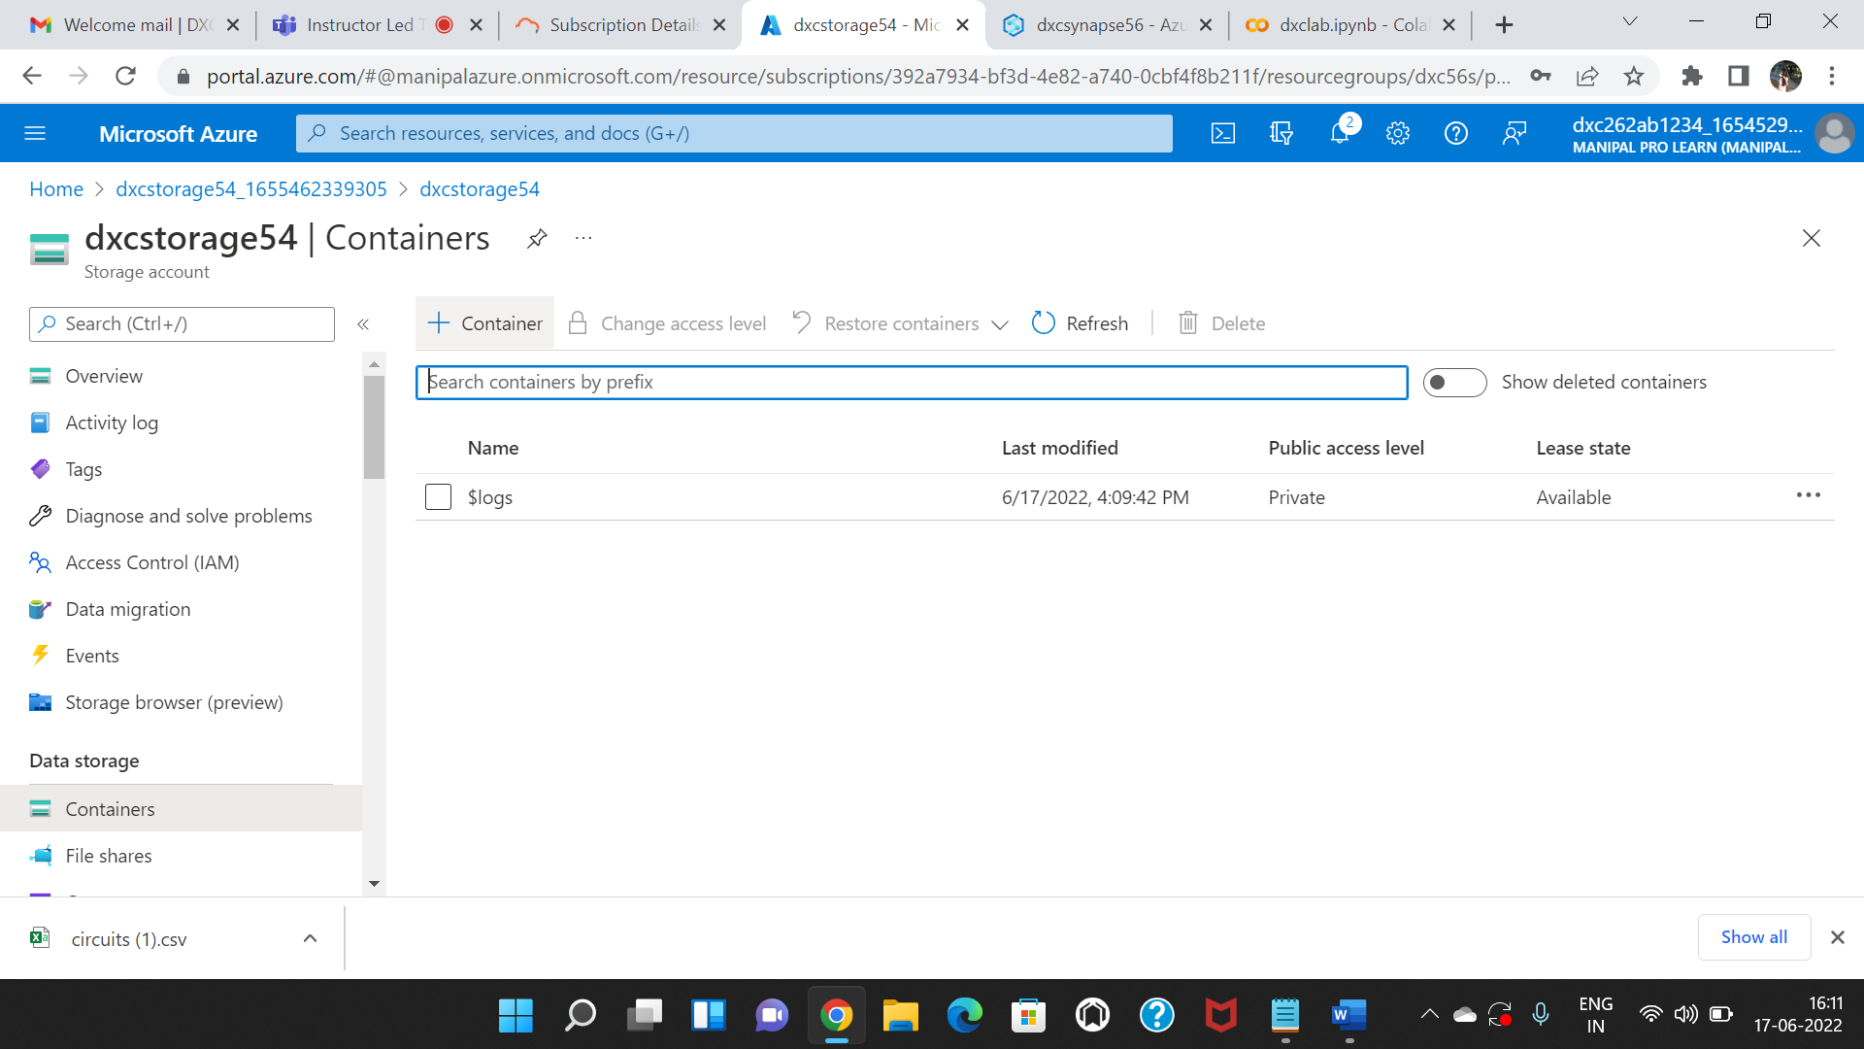

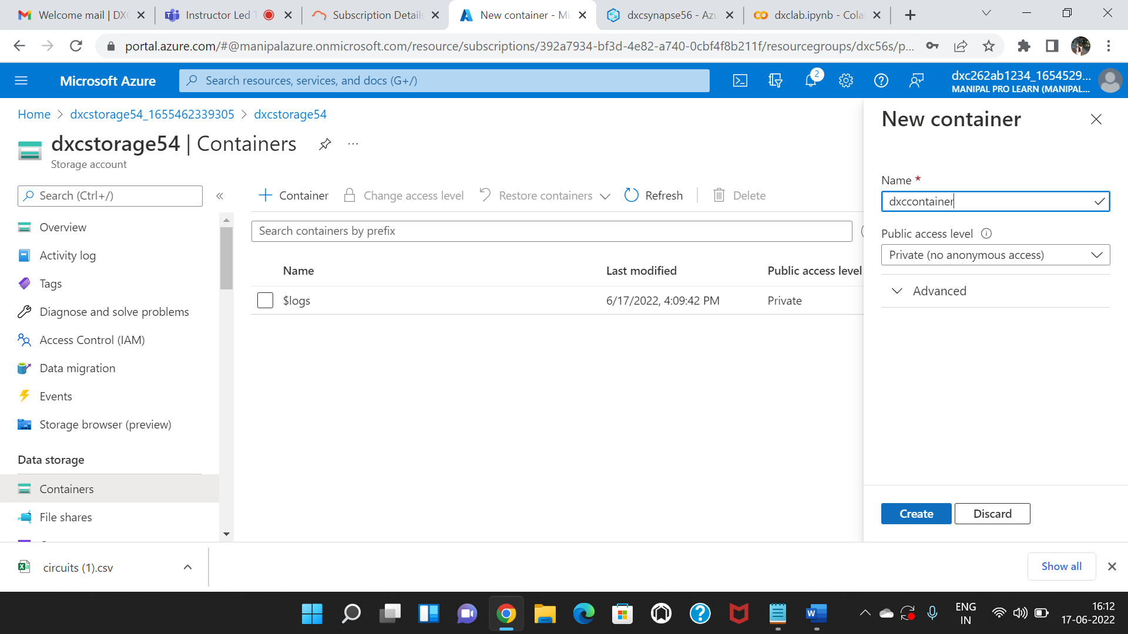

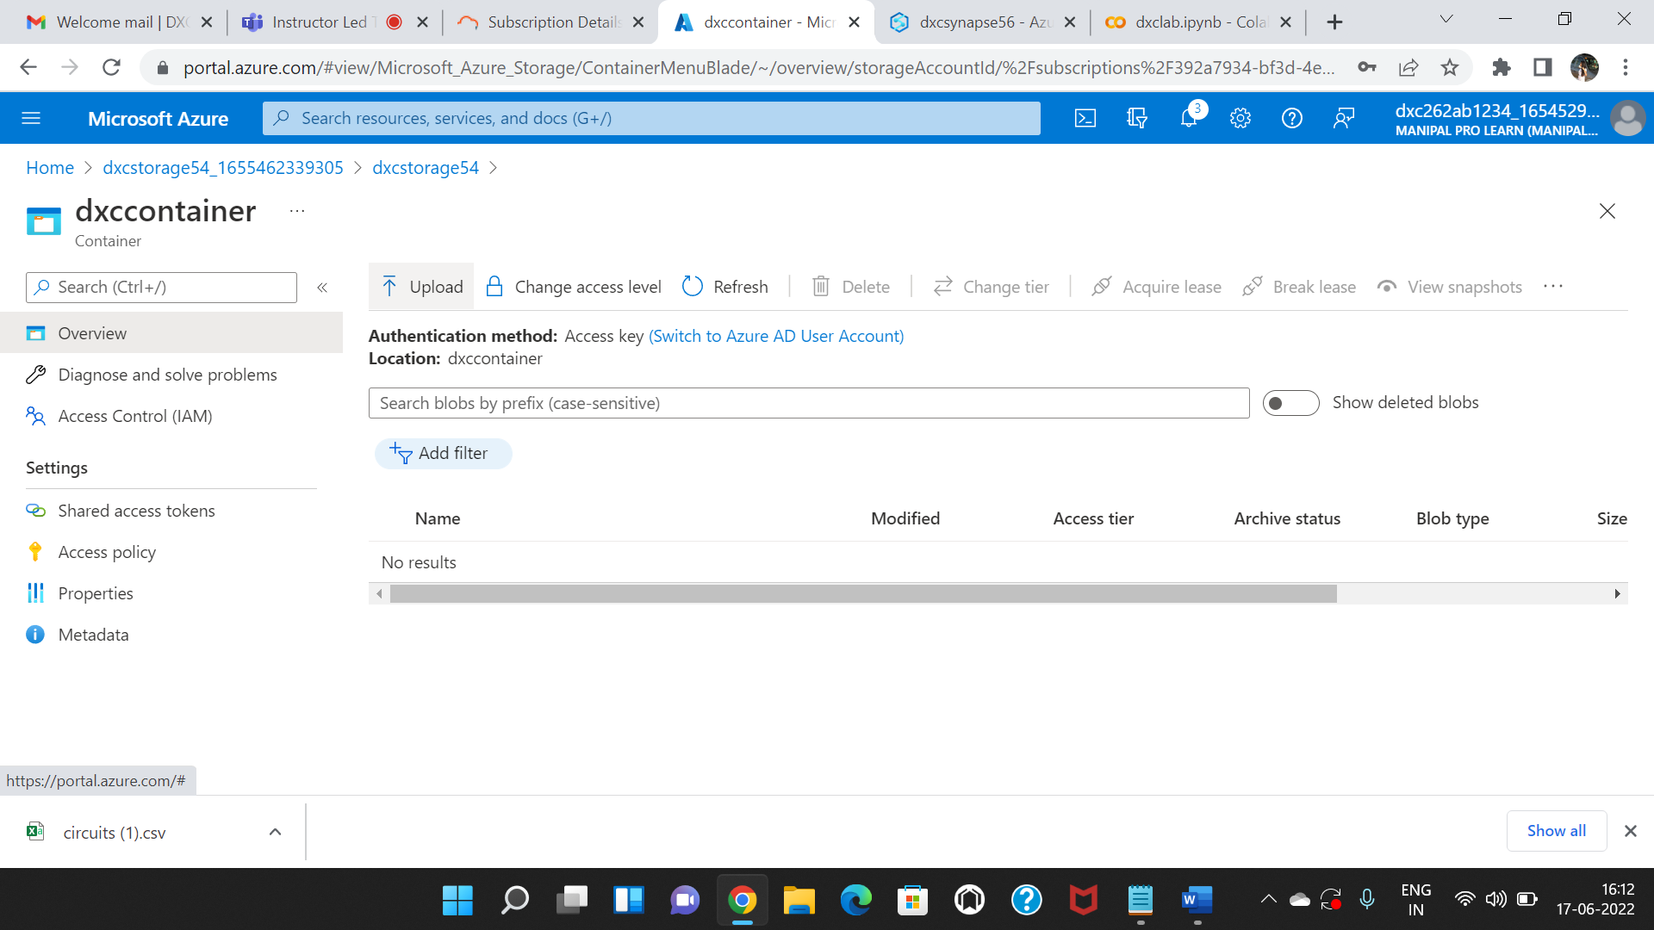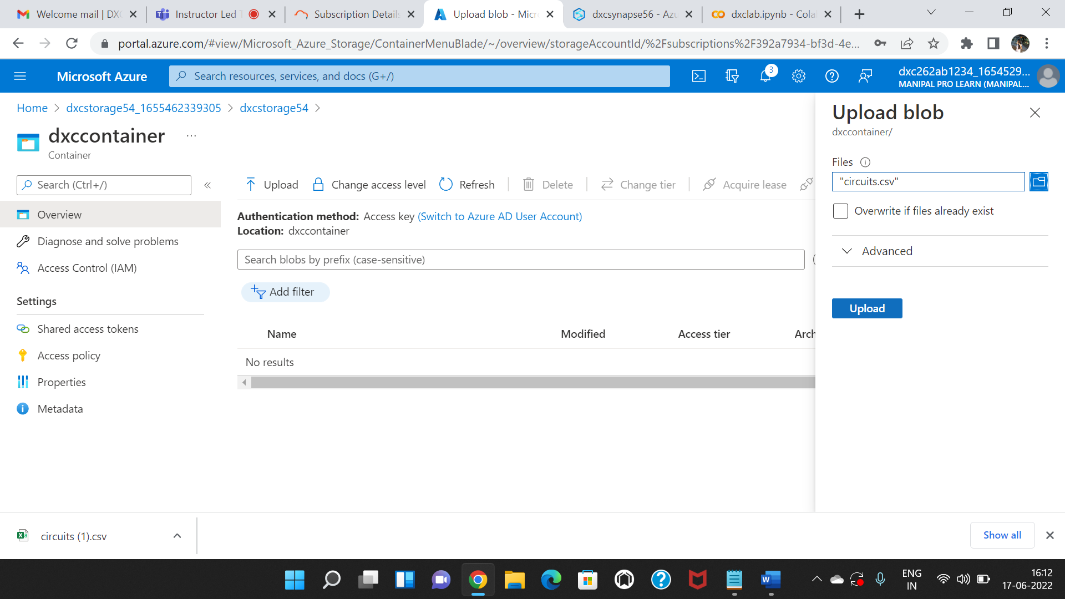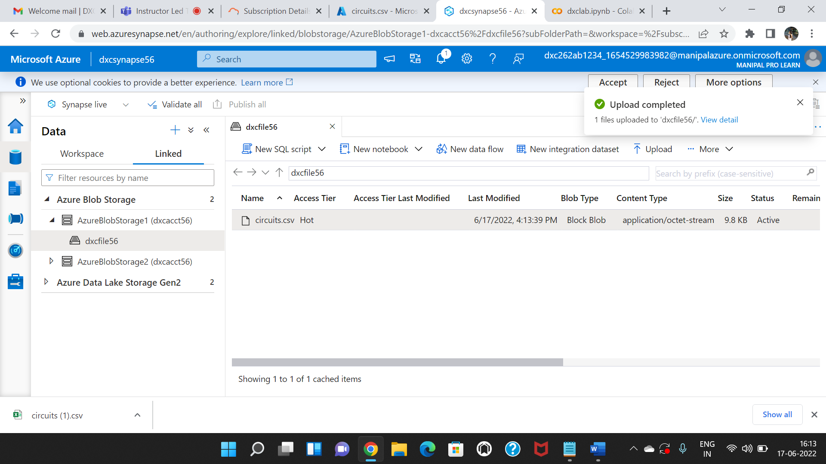



















4 min 49 sec

 - Apache Spark session











4 min 49 sec

 - Apache Spark session















4 min 49 sec

 - Apache Spark session

**5.Create Azure Synapse spark pool & query sample sample JSON file,explain the steps with screenshots**

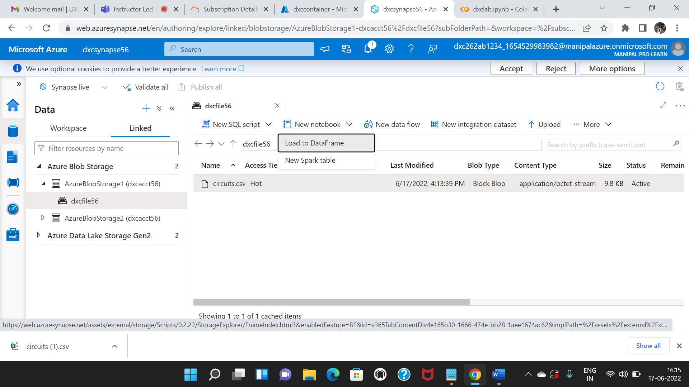

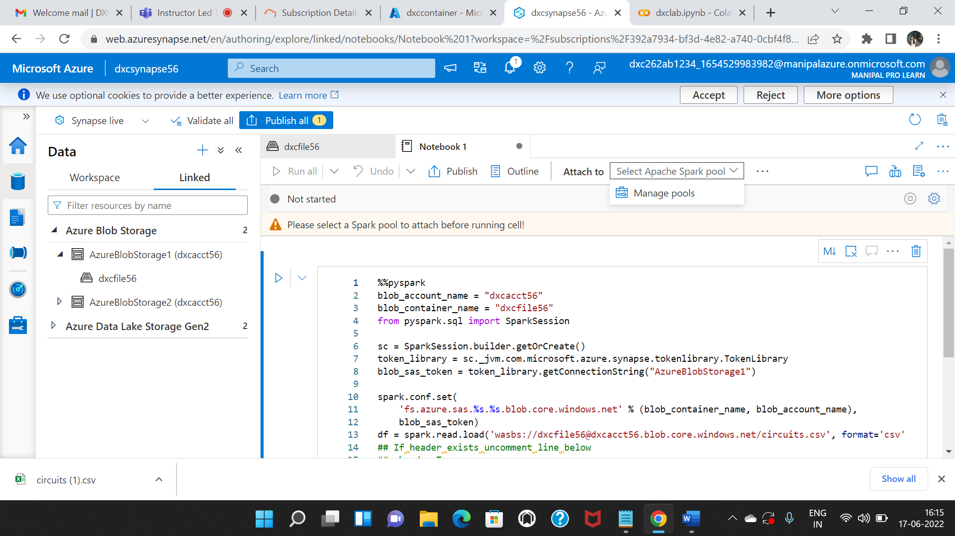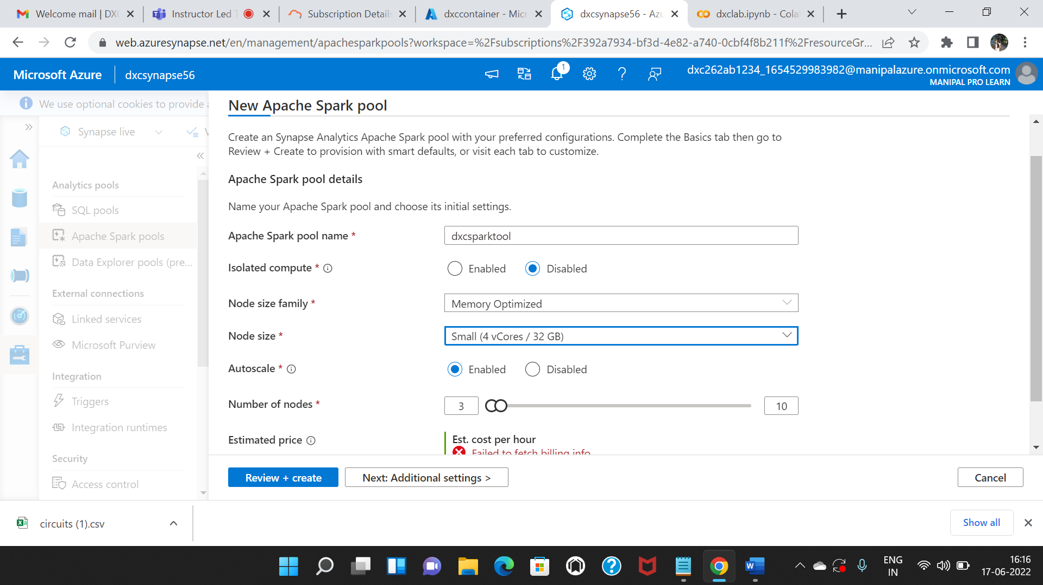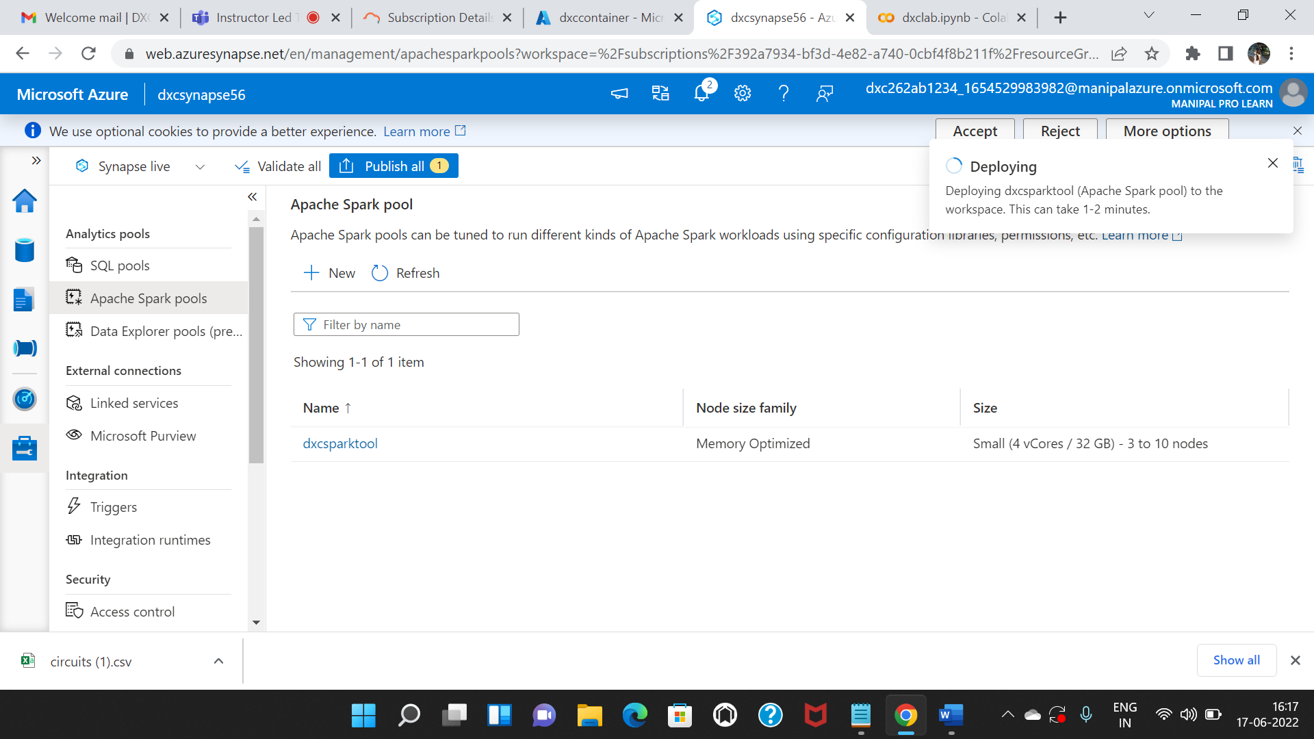

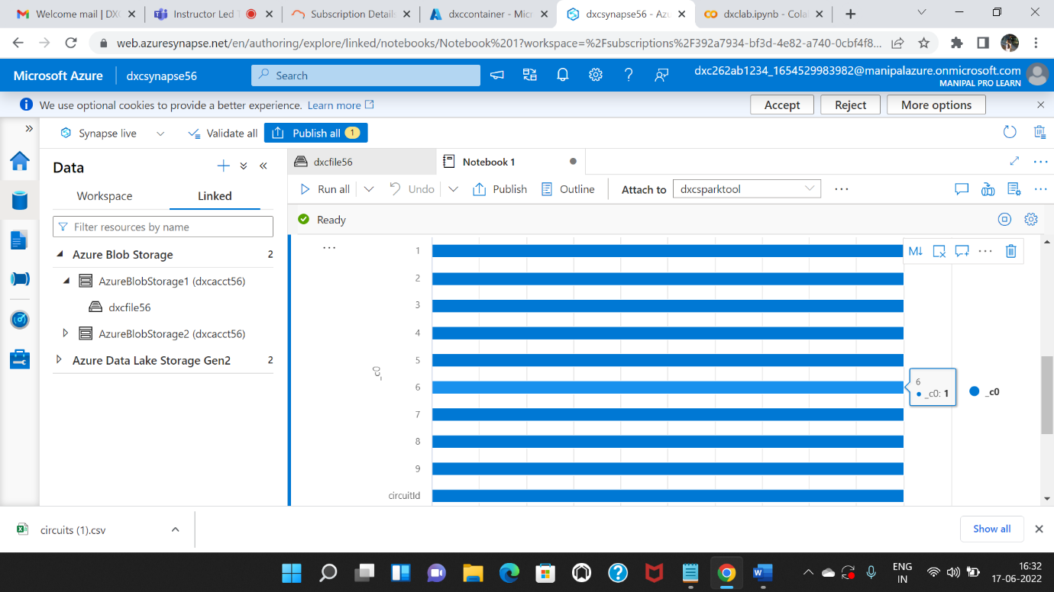

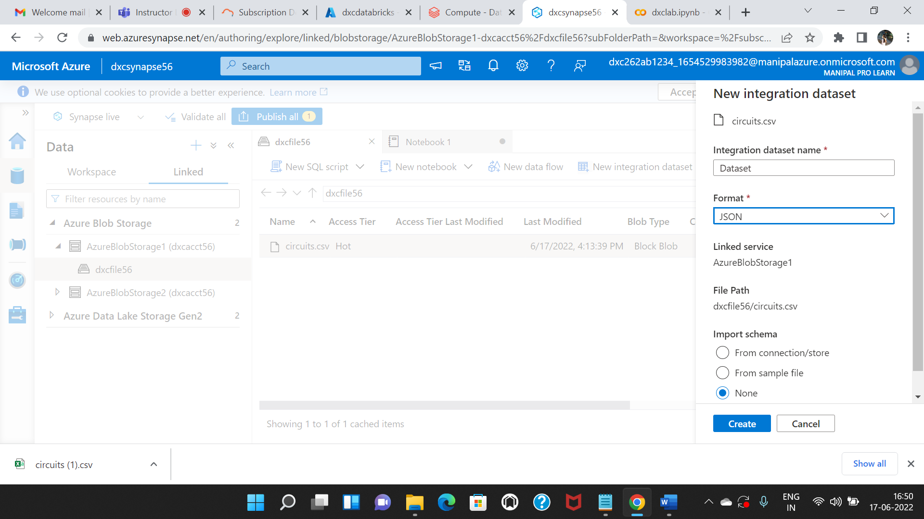

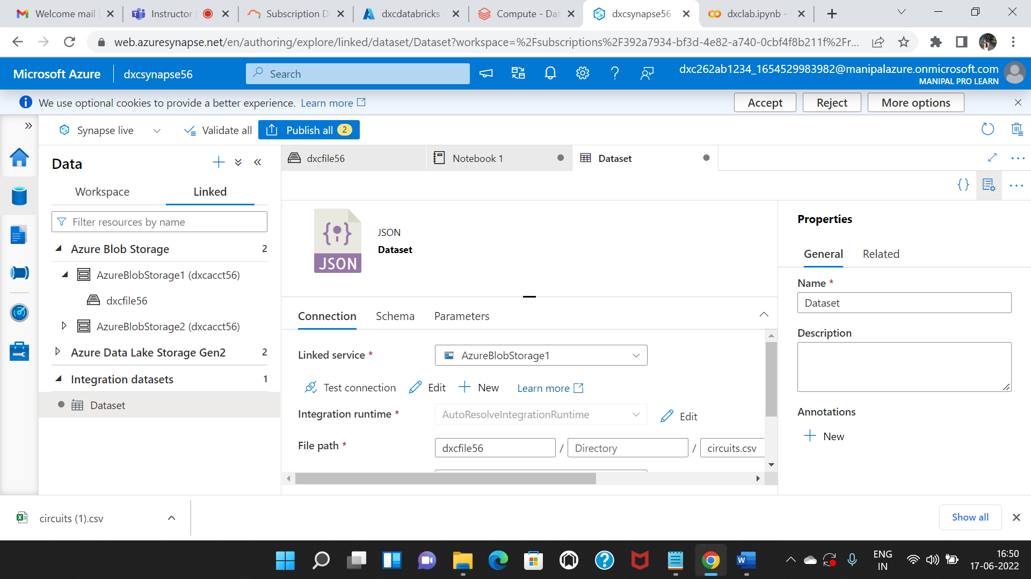

**6.Create Azure Cosmos DB & import sample JSON file, explain the steps with screenshots**

Cosmos DB can be used to store all kind of data including the Unstructured and semi-structured data i.e JSON data. Follow the steps in order to create a Cosmos DB account and upload JSON data into it.

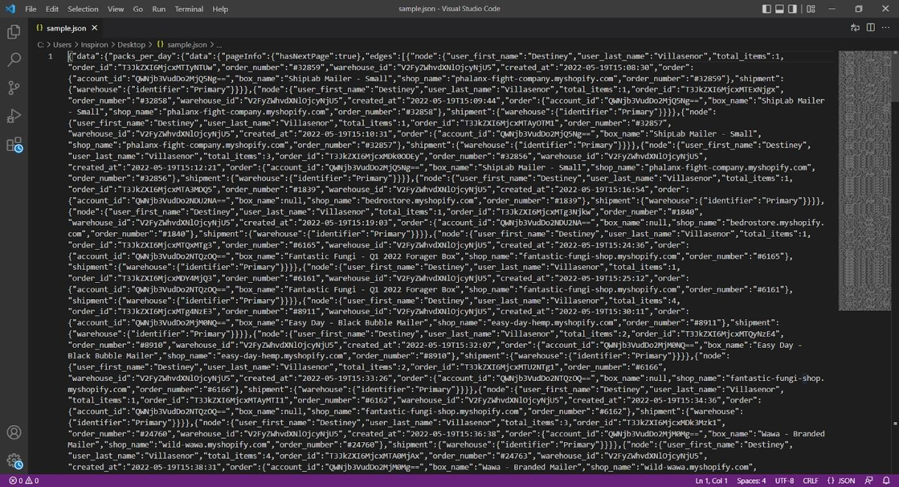

Sample JSON file to upload

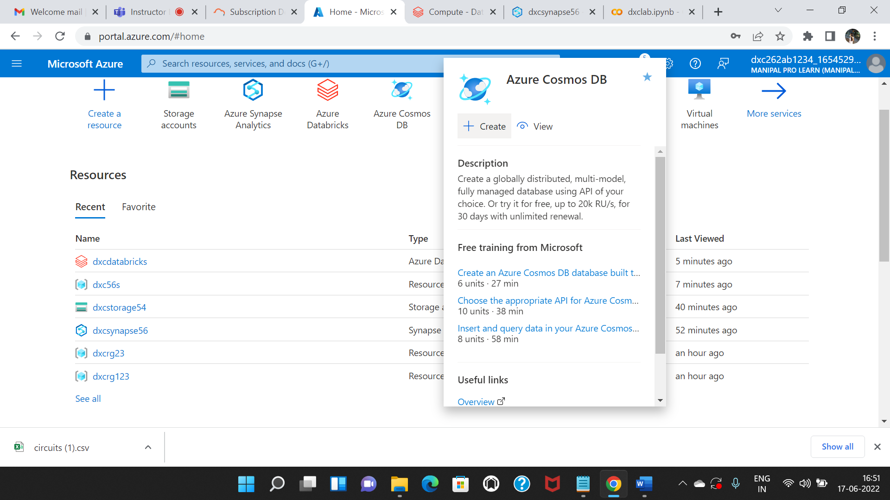

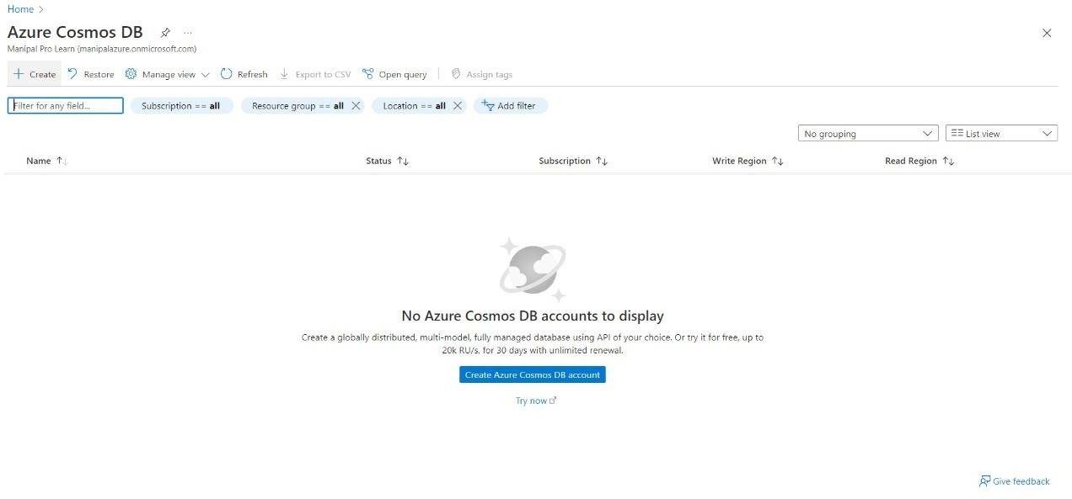

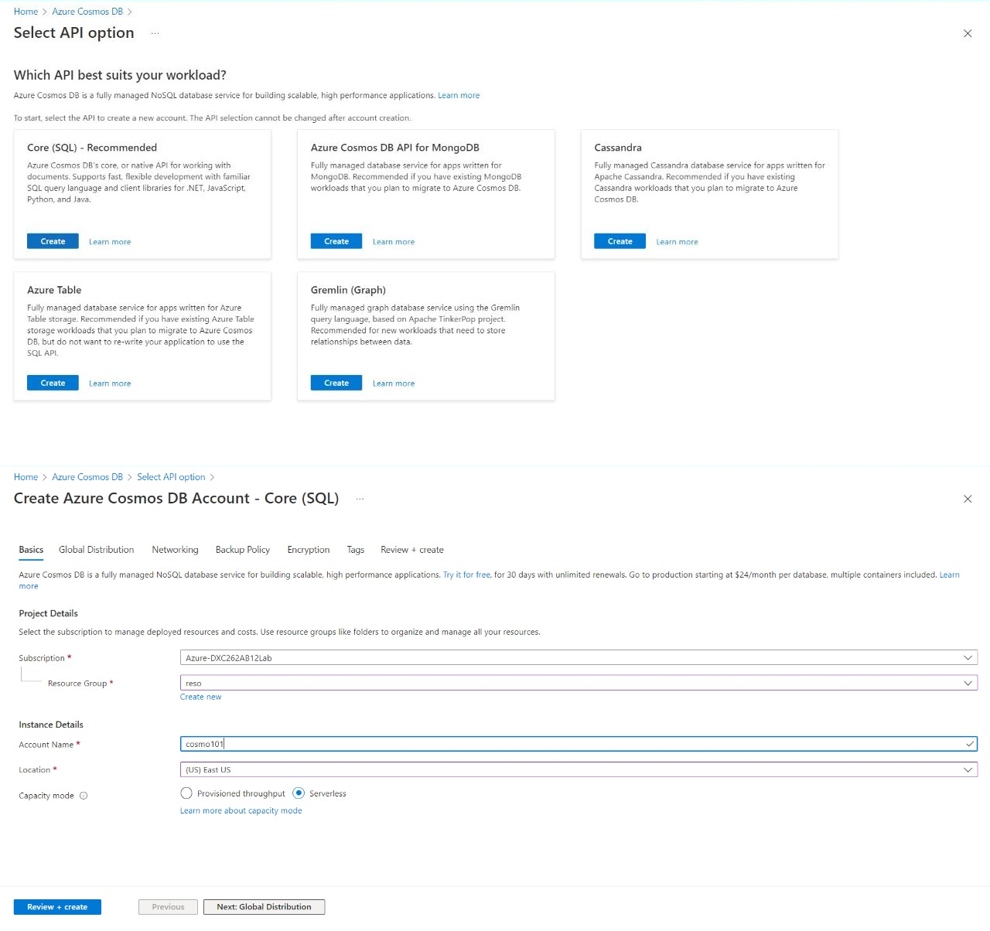

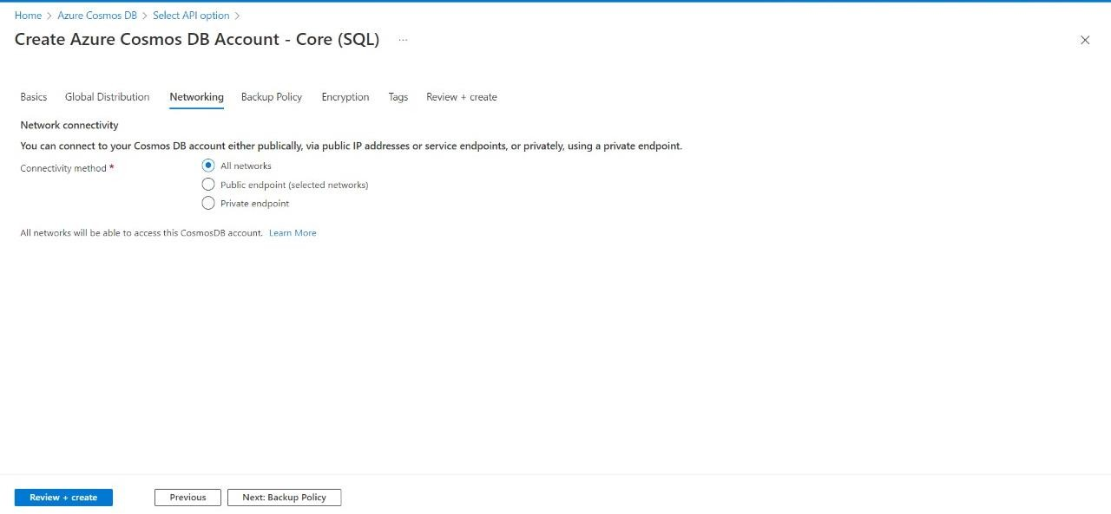

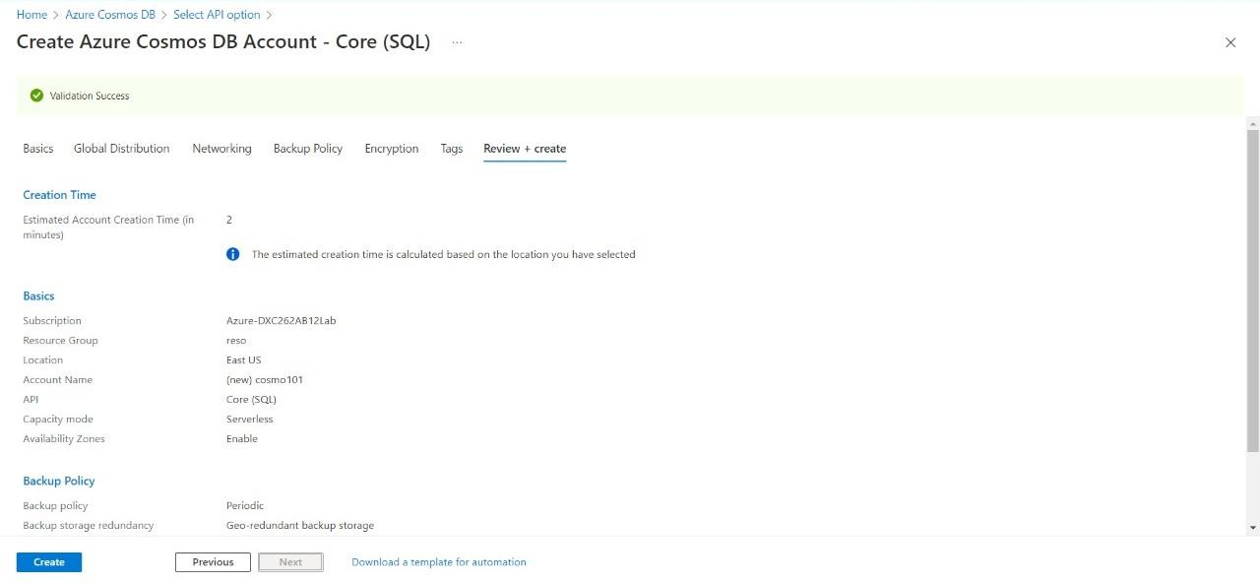

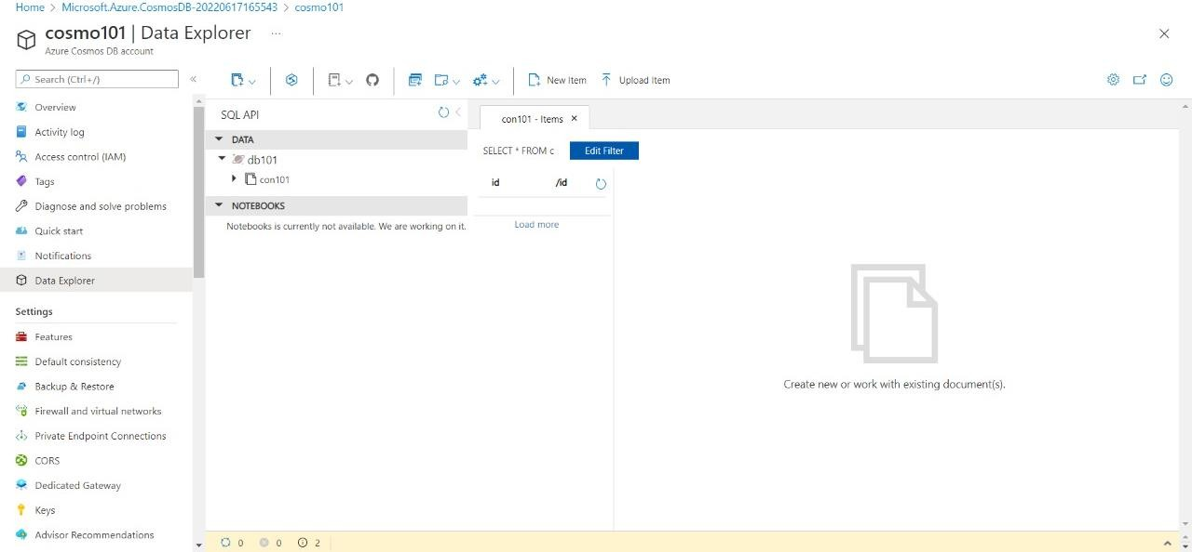

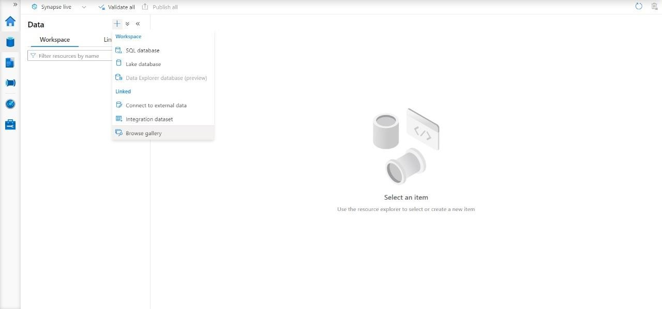

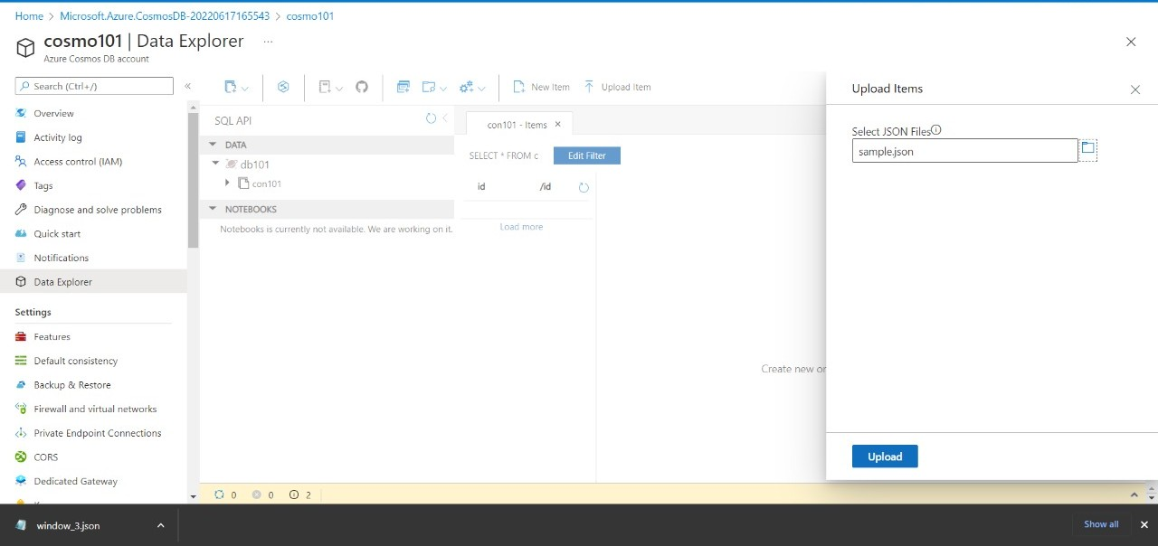

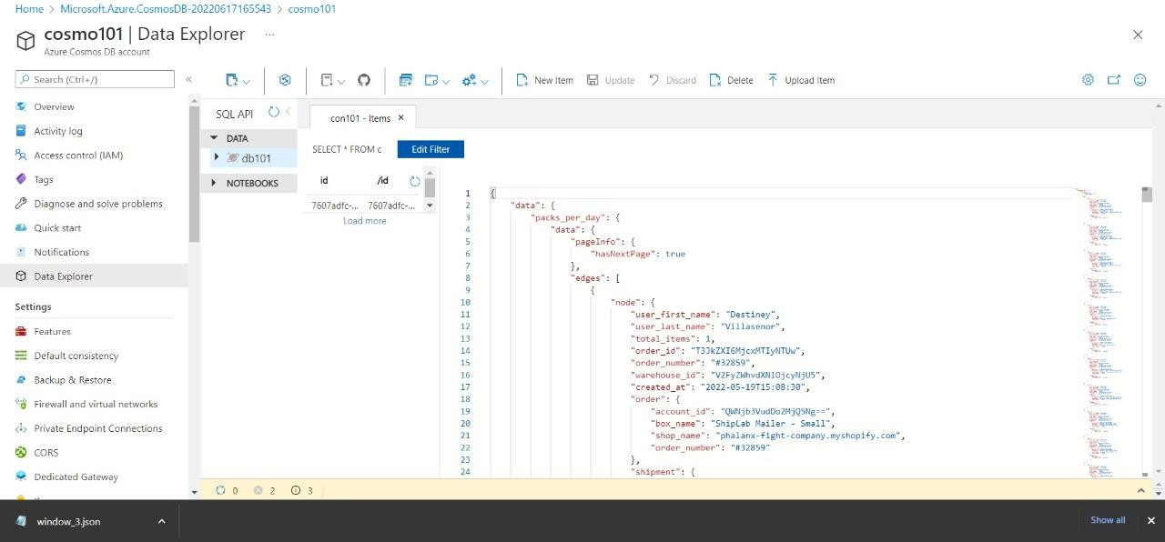

Now here we have successfully uploaded data into the Cosmos DB sql container.

**7.Connect COSMOS DB & Azure Synapse analytics & explain the steps with screenshots**

Azure Synapse can be connected to Cosmos DB using the following steps. For this question we are going to use cosmos DB account and synapse account from previous answers and will try to connect them

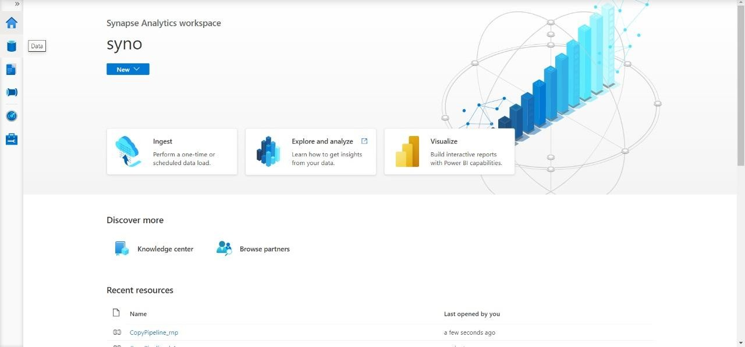



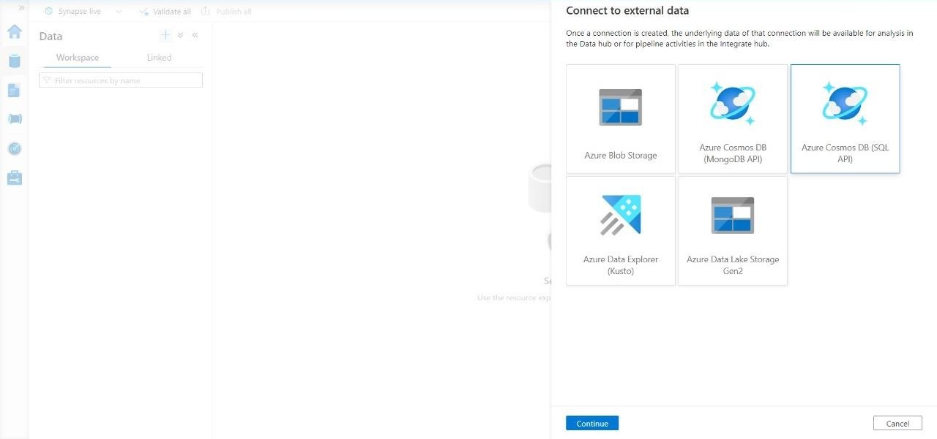

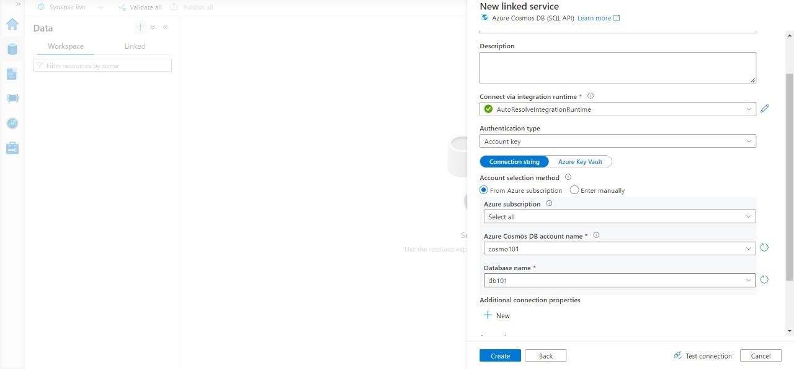

Here we have successfully loaded Cosmos DB sample json data into the Azure synapse lab.

**8.Create azure Data factory & azure Blob, connect Blob & ADF, import blob files into Data factory & explain the steps with screenshots**

Azure Data Factory is a tool to integrate and to create data workflows. In order to connect blob storage with Azure data factory follow the steps below.

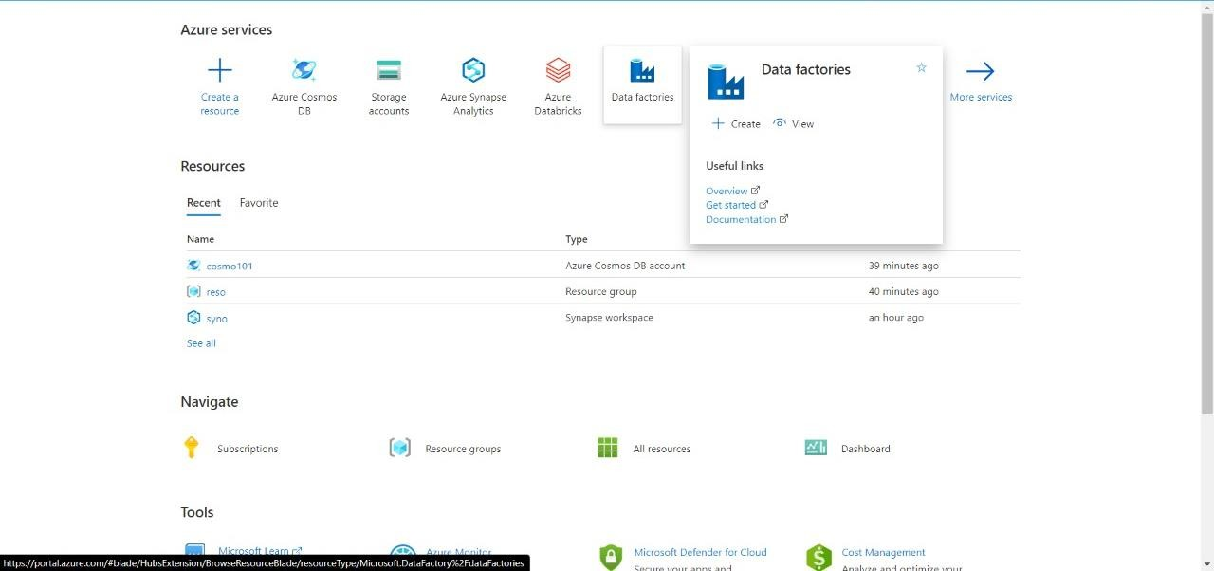

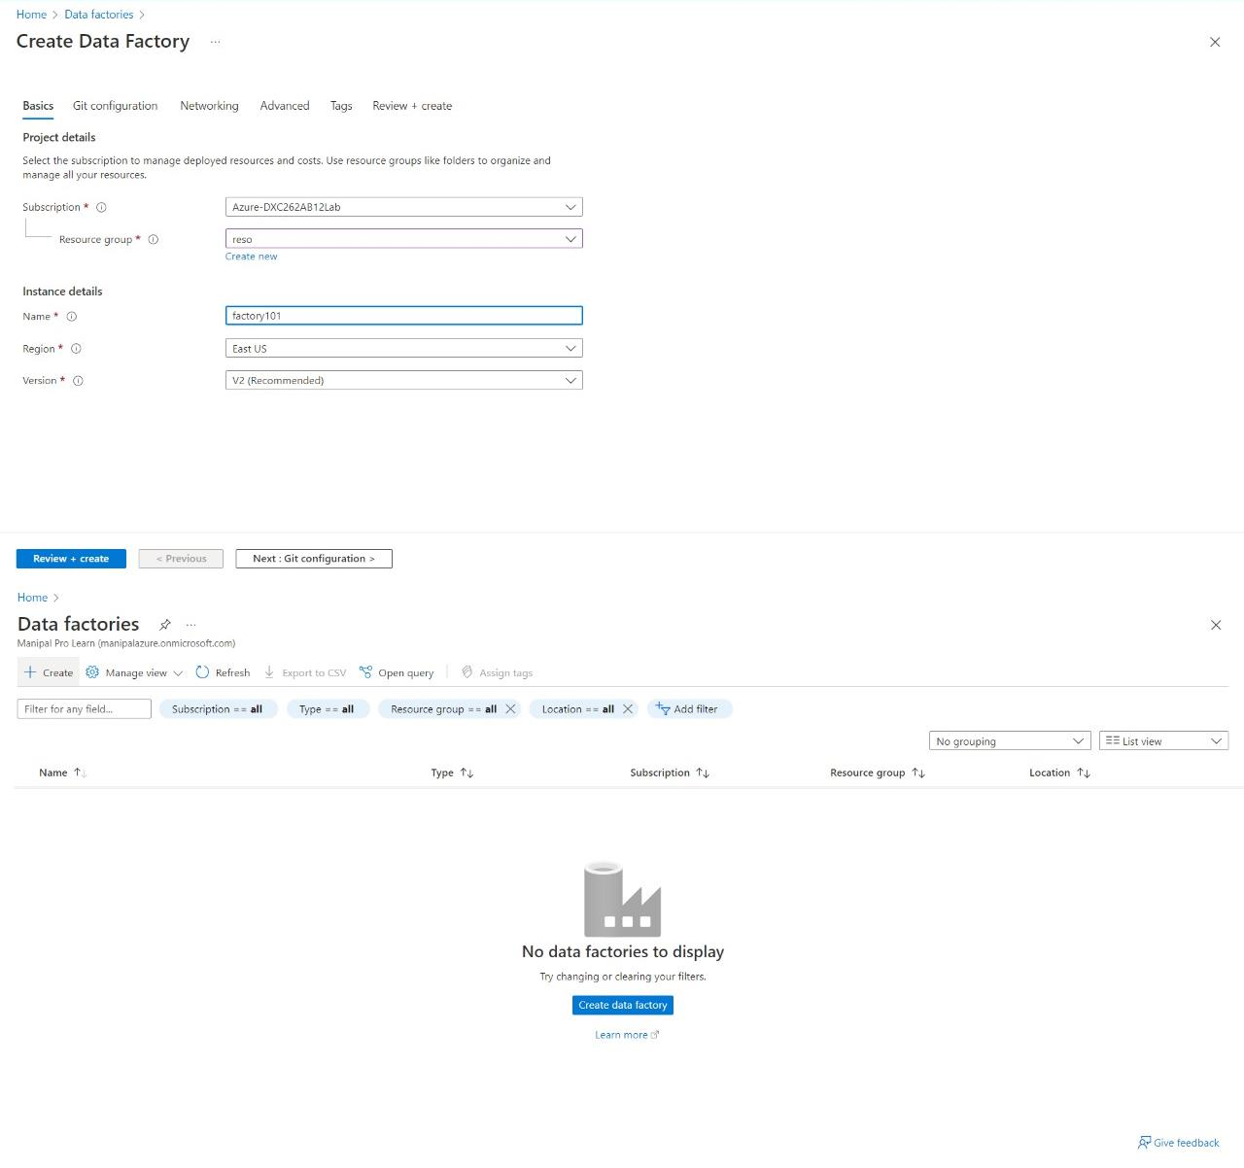

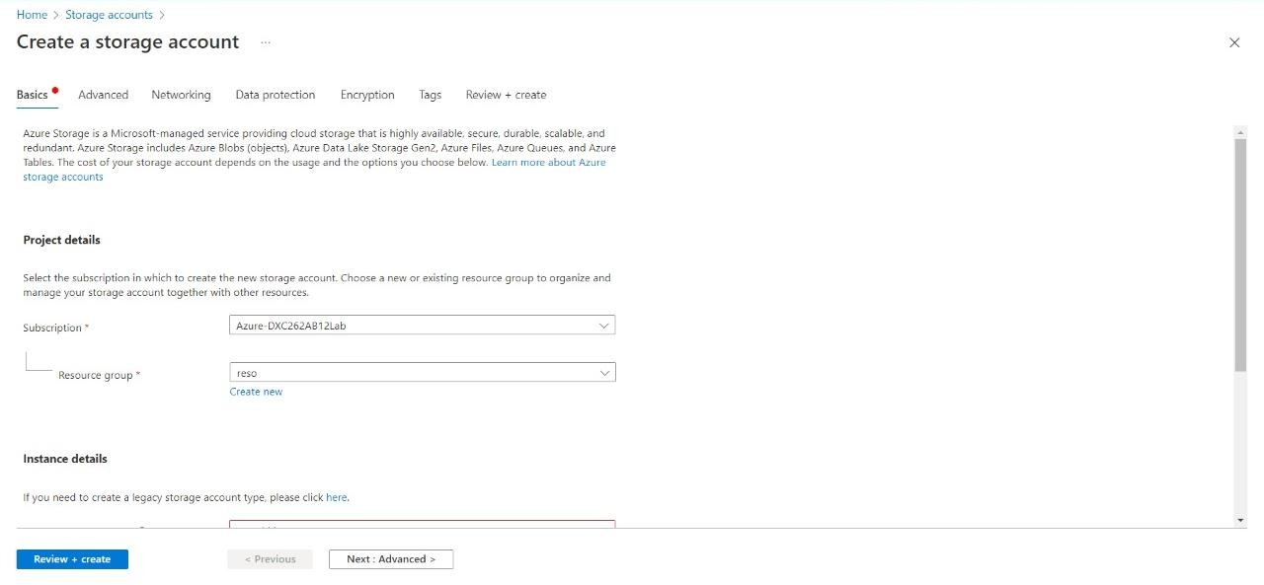

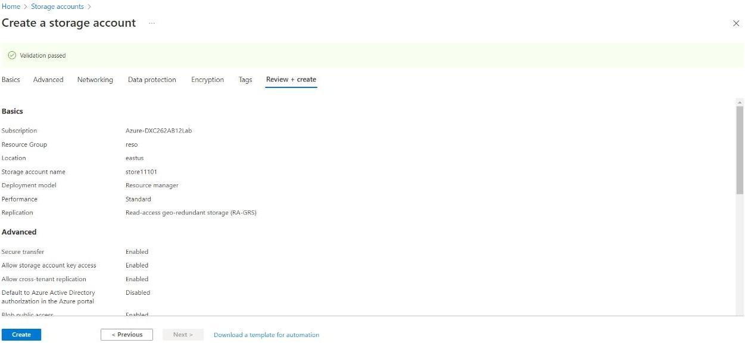

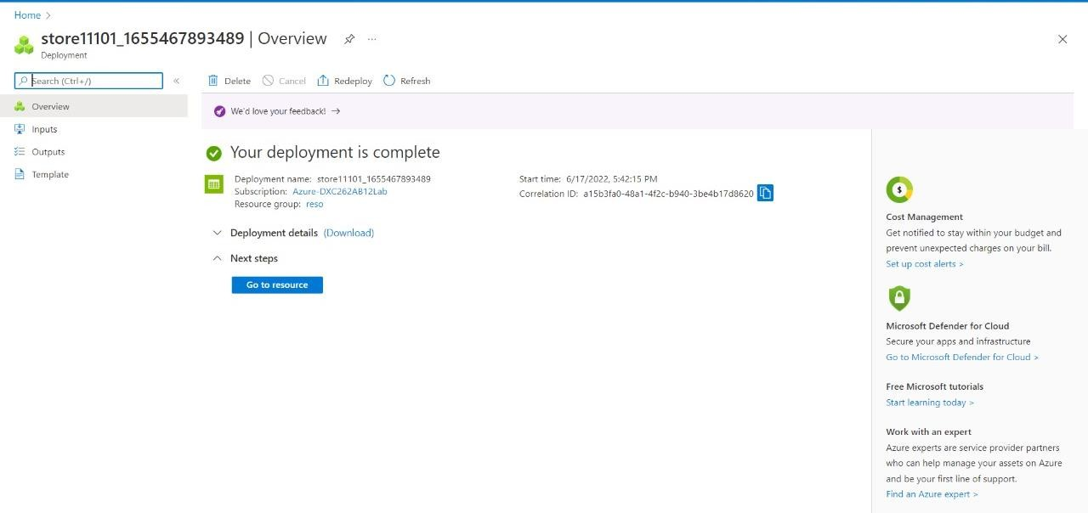

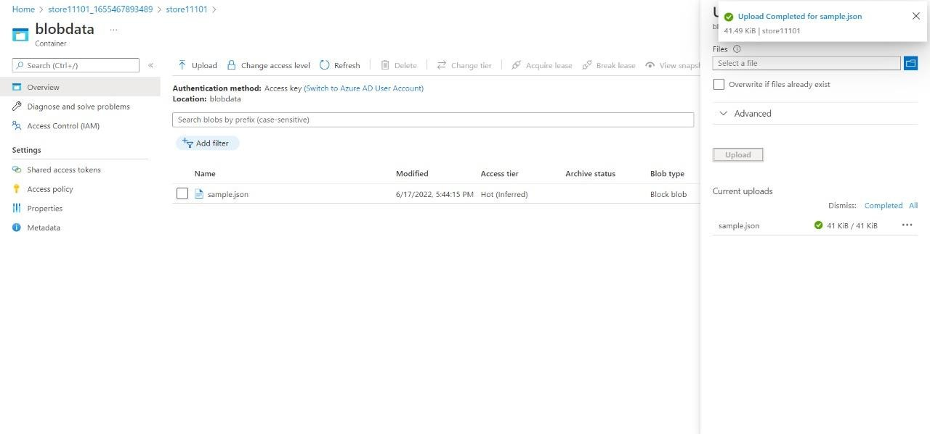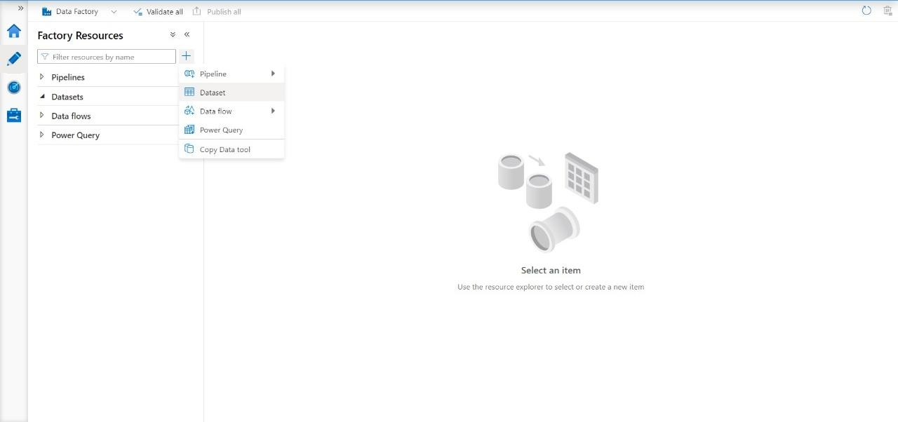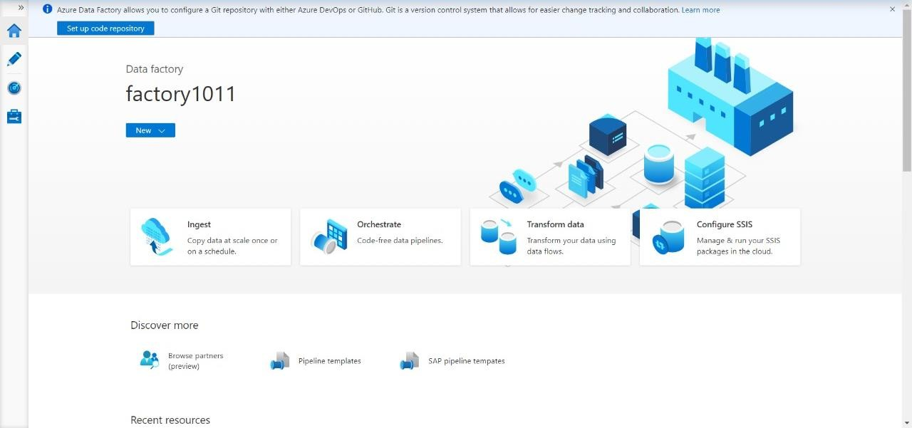

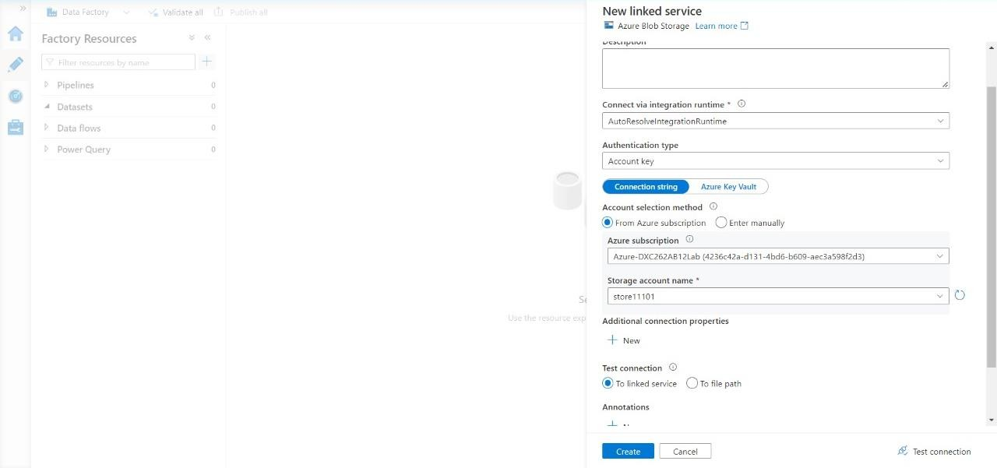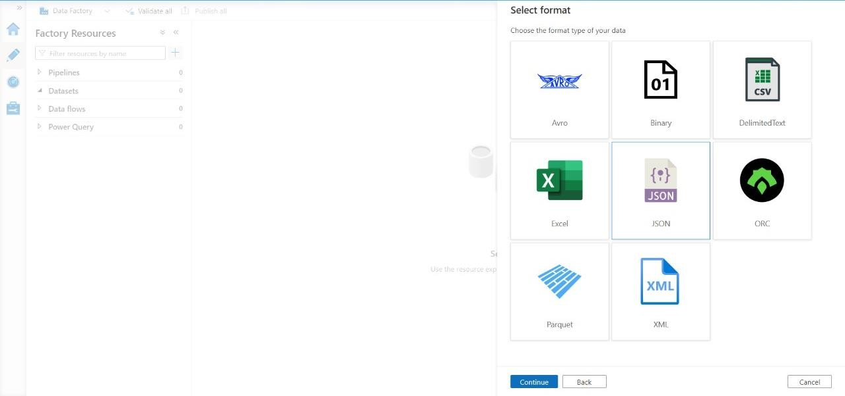

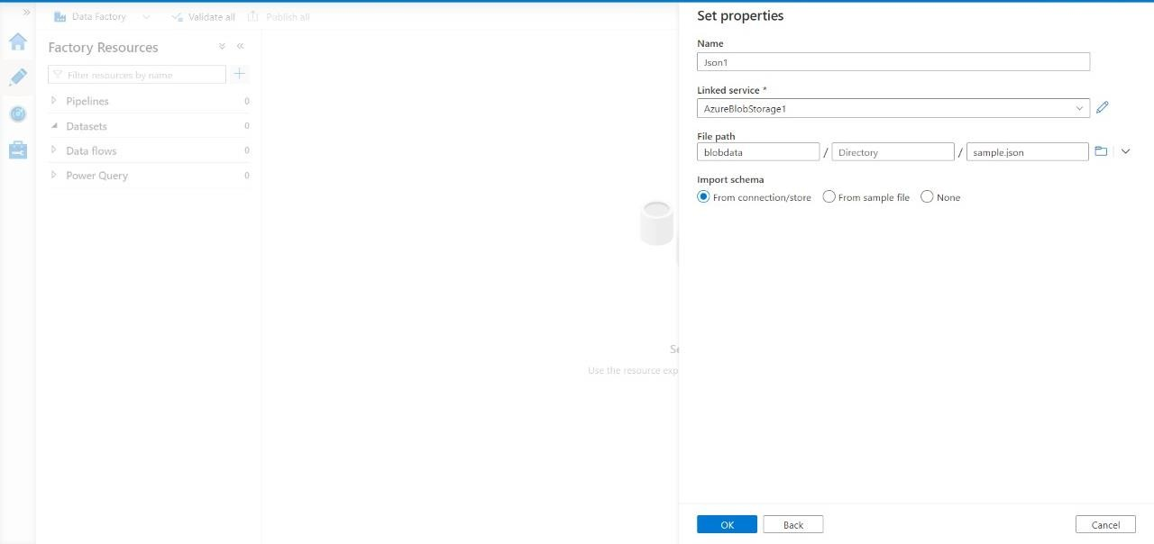

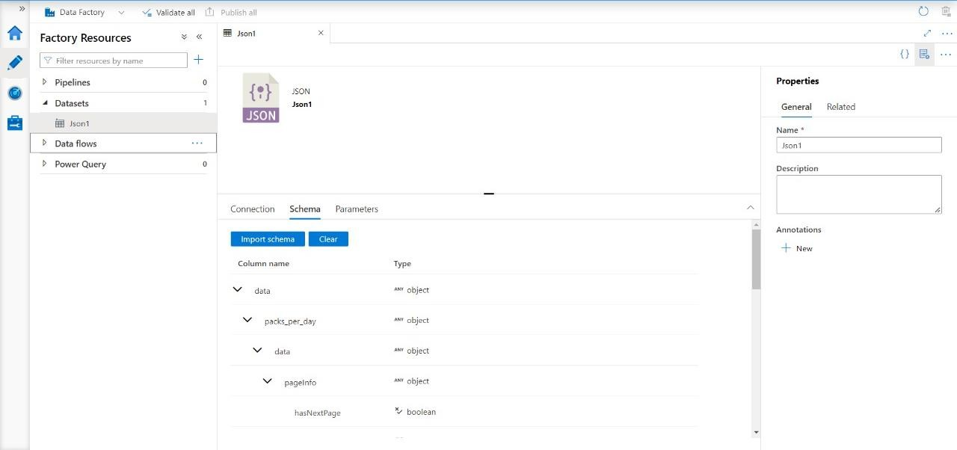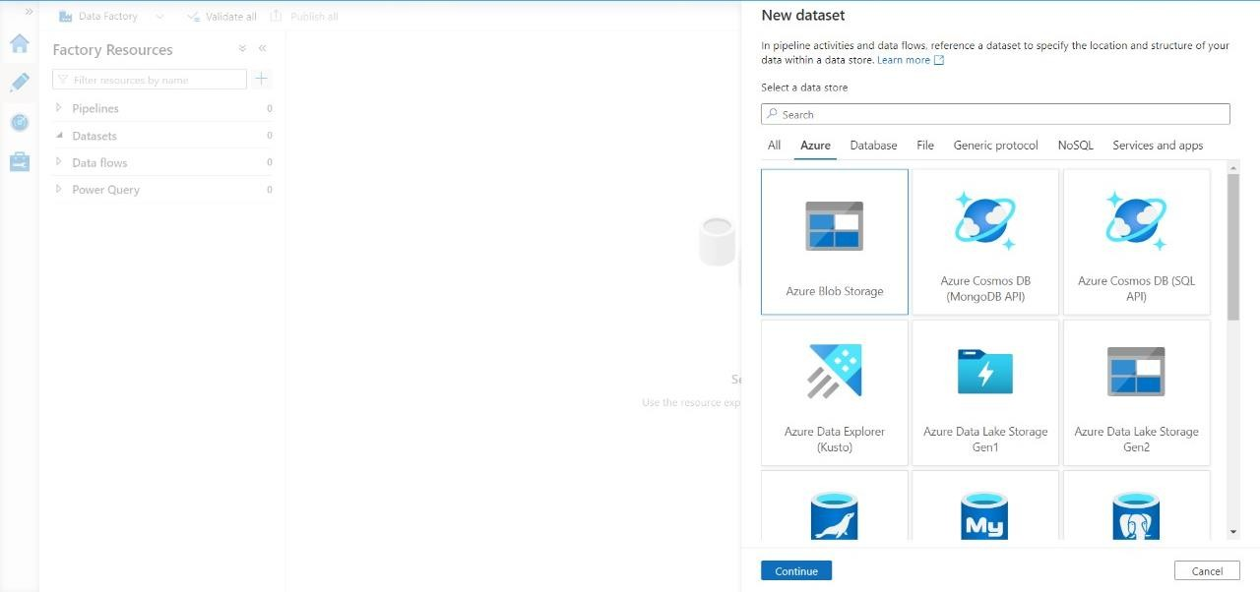

We have successfully created and linked a Azure data Factory and blob storage & imported the data into the Azure data factory.